
Commute Trip Reduction would not be possible without employee transportation coordinators or ETCs like you! You are the on-the-ground implementers.
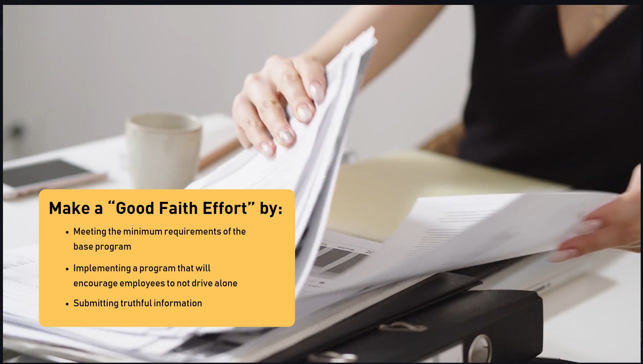
Remember, the Washington State Commute Trip Reduction law requires Employers to make a “good faith effort” to reduce the number of drive-alone commute trips. A “good faith effort” requires
- Meeting the minimum base program elements which we will cover in this video
- Implement a program that will encourage employees to not drive alone
- Submitting truthful information in reports and surveys

Now let’s talk about what ETCs do.

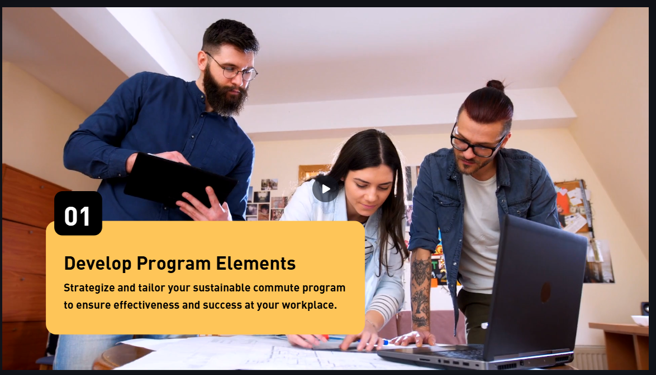
Develop program elements
You Strategize and tailor your commute options program to ensure effectiveness and success at your workplace.

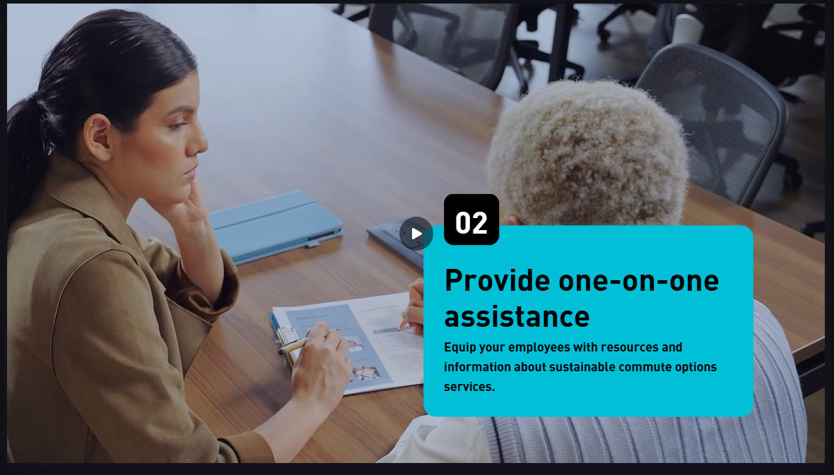
Provide one-on-one assistance
You equip your employees with resources and information about sustainable commute options.

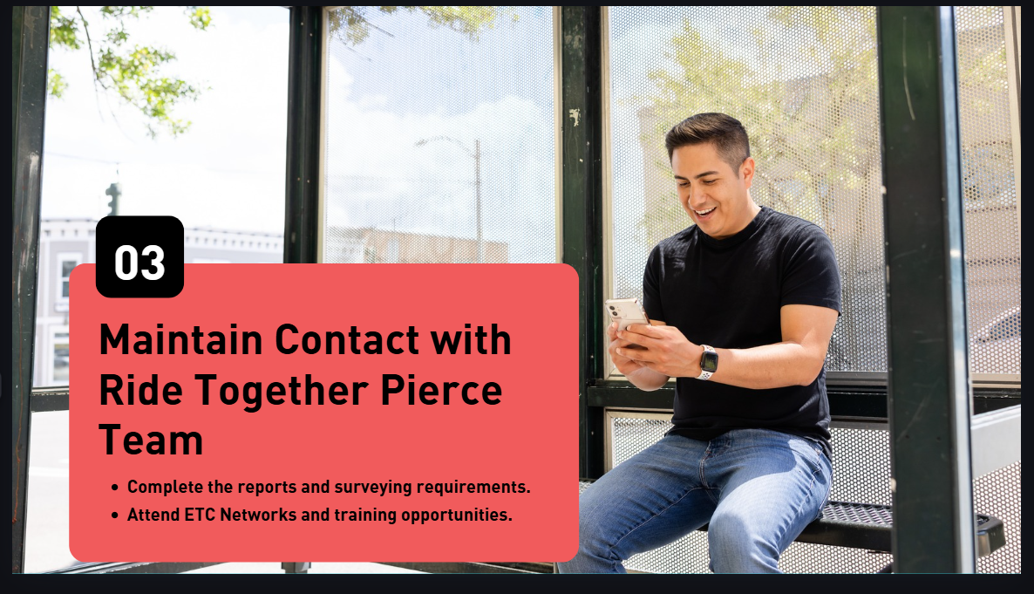
Maintain Contact with the Ride Together Pierce Team
- You complete the reports and surveying requirements.
- Attend ETC networks and training opportunities.

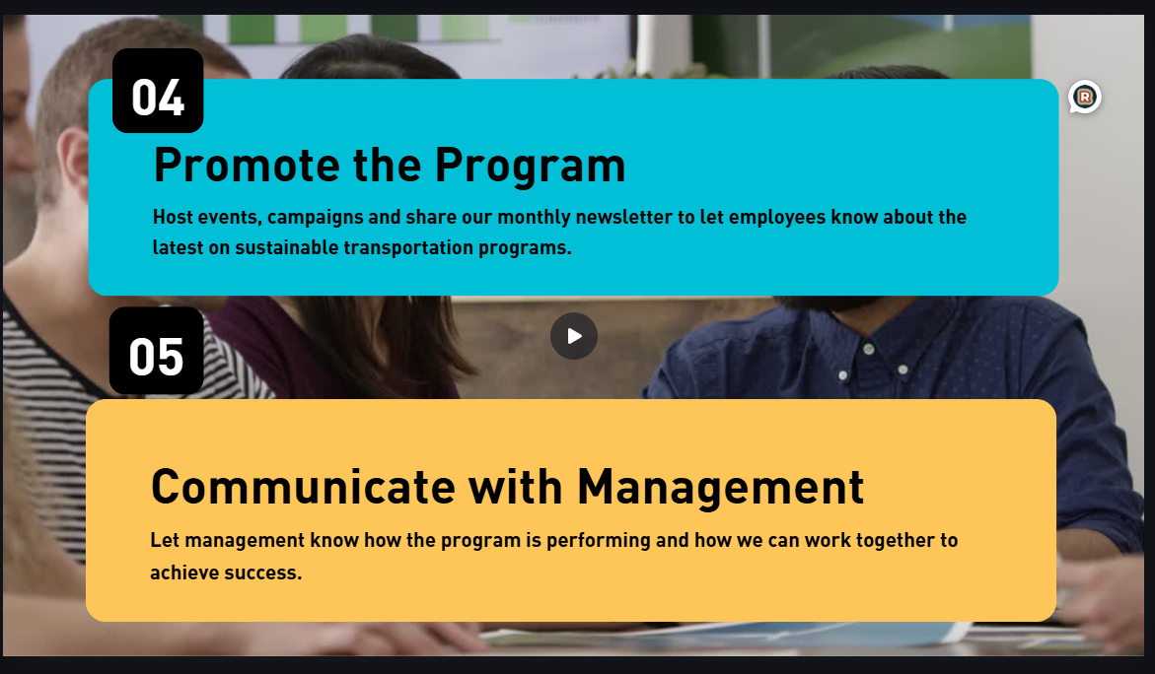
Promote the program
You host events, campaigns, and share our monthly newsletter to let employees know about the latest on sustainable transportation programs.

Communicate with management
Let management know how the program is performing and how we can work together to achieve success.

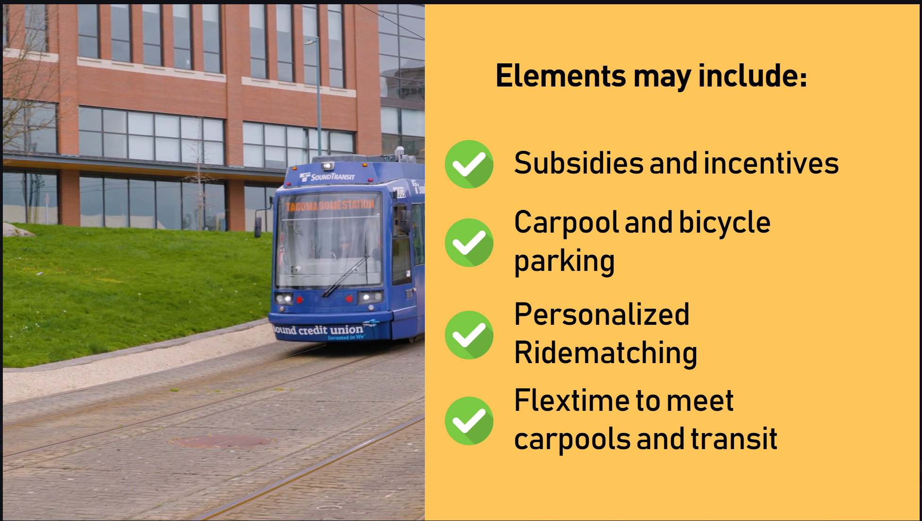
Employers must implement a commute options program with elements designed to encourage employees to use sustainable modes. The elements should be tailored to your workplace and may include things like:
Transit subsidies like a provided ORCA card
Incentives or prizes
Priority parking for carpools or vanpools
Secure and covered bike parking
Maintaining a vanpool match list
Allowing work from home
Flex time for carpools, van pools, or compressed work weeks


One reason some people do not use sustainable transportation modes for their commute is fear of an emergency like having to leave work to pick up a sick child from school. This is why we require all employers to have an Emergency Ride Home program. You can create your own program, or use Ride Together Pierce’s free program

Pop quiz! What is the most important program element?
The correct answer is, you! The engaged Employee Transportation Coordinator

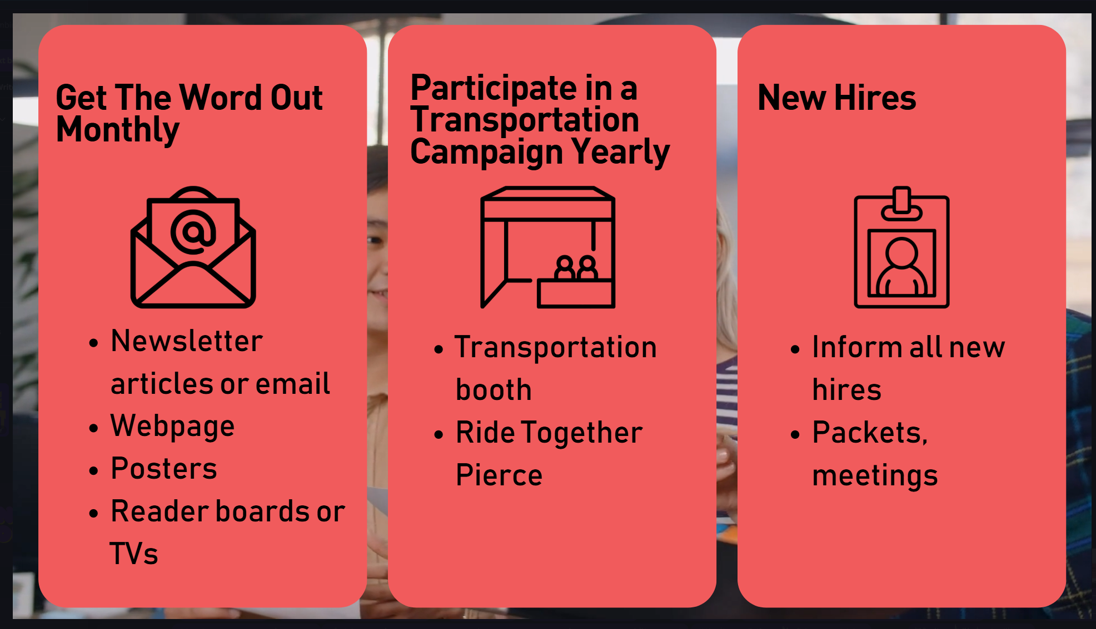
You must promote your commute options program at least a month. You can do so through Newsletter articles, email, your webpage, posters, electronic reader boards, or tvs, or other options. We suggest you mix it up, not just relying on email.

You must participate in at least one transportation campaign a year. You may take advantage of campaigns from Ride Together Pierce like Bike Month. Another option is to have a transportation booth at your employer’s benefits fair or annual barbeque.

Information needs to be provided to all new hires. A good packet would include a brochure explaining your program, a promotion of ride matching services, and a letter from your CEO encouraging sustainable transportation. If you can, you could even call or meet with each new employee.
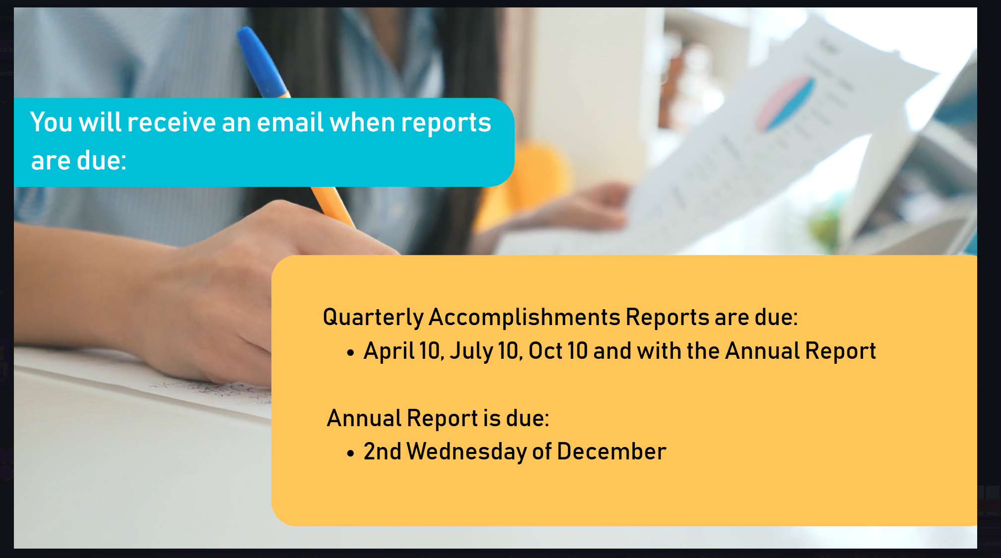
Reporting requirements

All employers must also submit quarterly and annual reports. The quarterly reports simple bullet responses of work you completed last quarter. The annual report is a more comprehensive report of your program elements and worksite amenities. We suggest keeping a document recording your work to make reporting easier. The Ride Together Pierce team will send email reminders when reports are due.
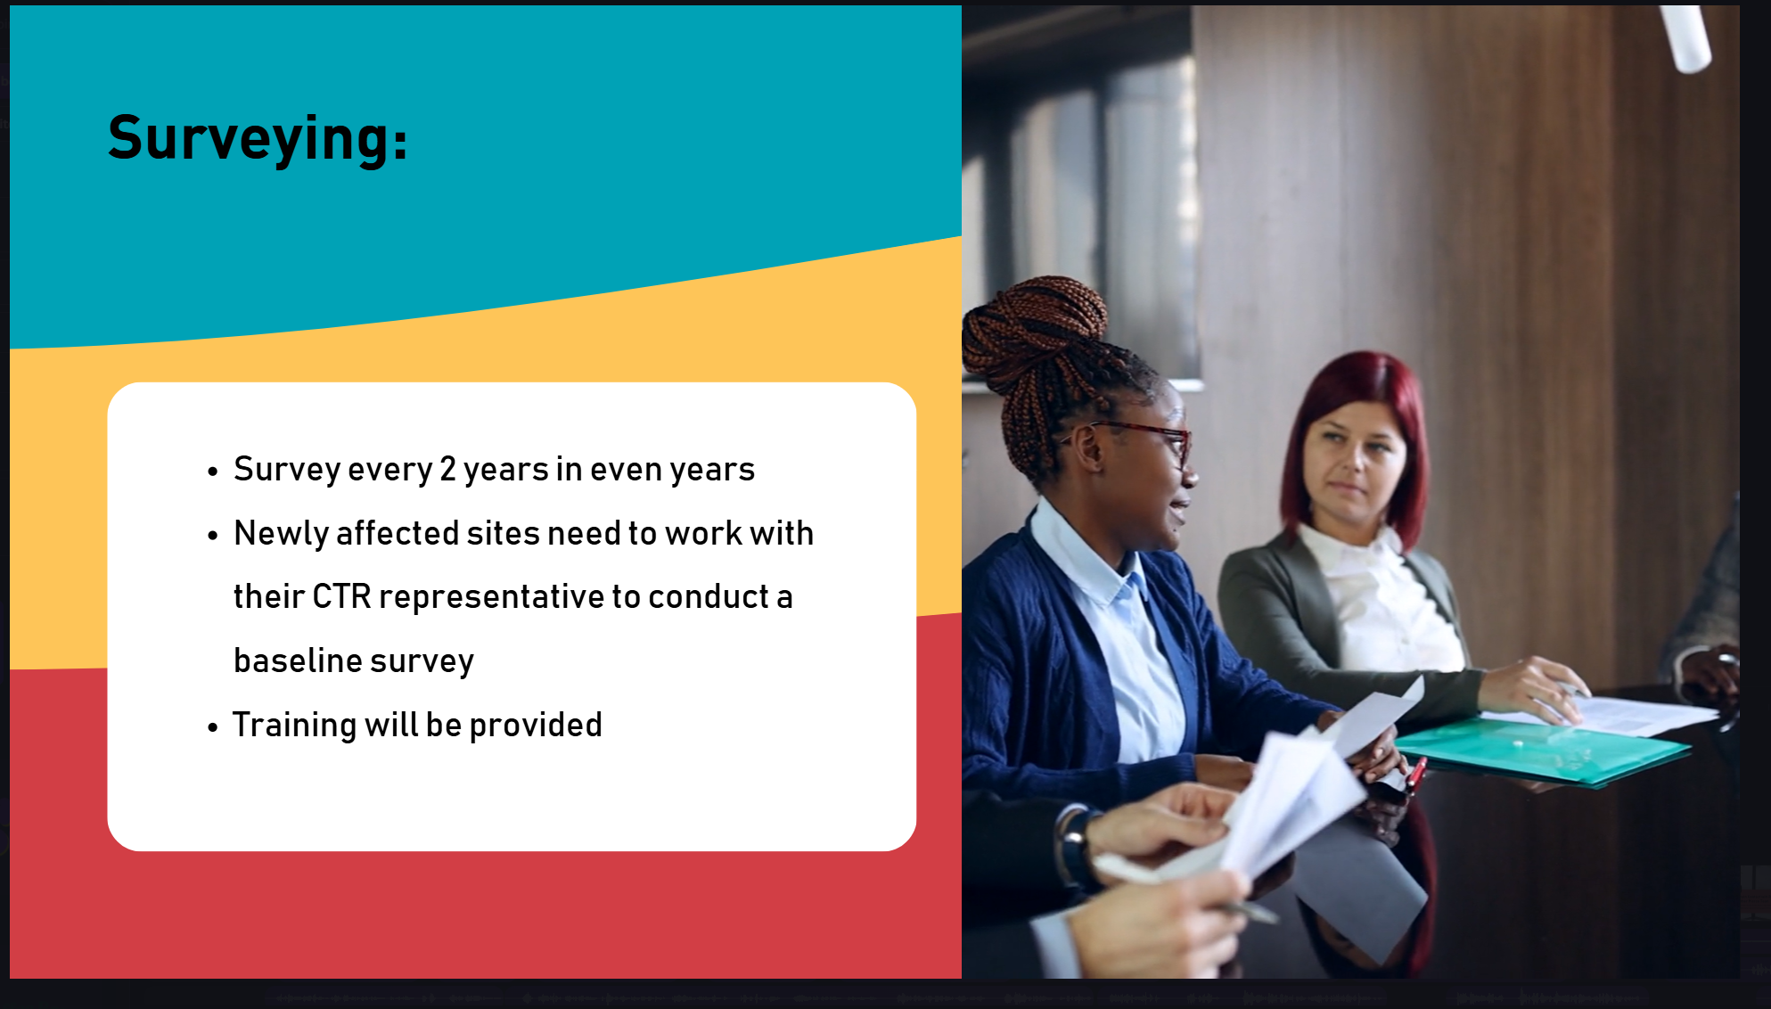
Employers must survey employees every 2 years to measure the progress towards shifting employees to sustainable commute options. Surveys take place in the Spring and training will be provided.

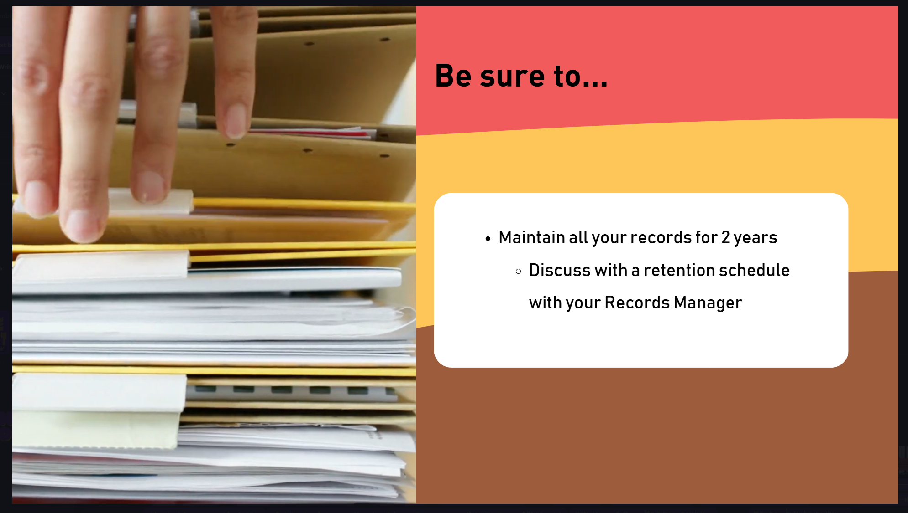
You need to maintain all official records for two years. Every employer program is different, you will need to work with your records manager to establish a retention plan


Pause the video and write down a few ways you can improve your new hire materials.

