Gaining Management Support
Voiceover Script and Notes

Slide 1:
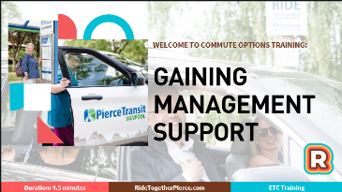
Notes: ____________________________________________________
__________________________________________________________
__________________________________________________________
__________________________________________________________
__________________________________________________________
Music

Slide 2:
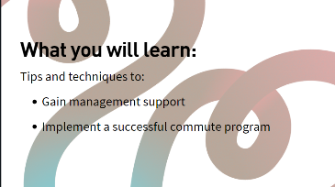
Notes: ____________________________________________________
__________________________________________________________
__________________________________________________________
__________________________________________________________
__________________________________________________________

From this video you will learn tips and techniques to gain management support and implement a successful commute program.

Slide 3:
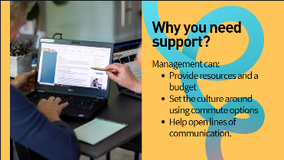
Notes: ____________________________________________________
__________________________________________________________
__________________________________________________________
__________________________________________________________
__________________________________________________________

Why do you need support as an Employee Transportation Coordinator? Management can provide resources and a budget, set the culture around using commute options, and help open lines of communication.

Slide 4:
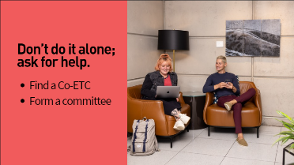
Notes: ____________________________________________________
__________________________________________________________
__________________________________________________________
__________________________________________________________
__________________________________________________________

Most importantly, don’t do it alone. Ask management to help find a Co-Employee Transportation Coordinator or form a small committee. By doing so, you can divide the workload, gather input and ideas--and your employees will have access to another expert.

Slide 5:
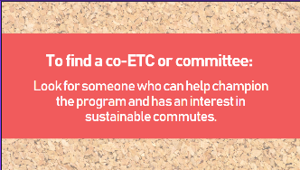
Notes: ____________________________________________________
__________________________________________________________
__________________________________________________________
__________________________________________________________
__________________________________________________________
To find a Co-Employee Transportation Coordinator or committee, look for someone who can help champion the program and has an interest in sustainable commutes.

Slide 6:
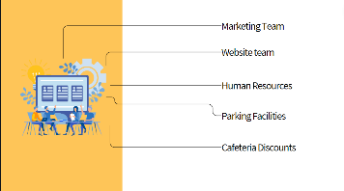
Notes: ____________________________________________________
__________________________________________________________
__________________________________________________________
__________________________________________________________
__________________________________________________________

You will need resources to support your program. Resources can include your marketing team, website team, human resources, parking or facilities department for HOV and bicycle parking, showers, or cafeteria discounts.

Slide 7:

Notes: ____________________________________________________
__________________________________________________________
__________________________________________________________
__________________________________________________________
__________________________________________________________

Managers can help set expectations by endorsing the use of sustainable commute options. They can lead by example by using a sustainable commute option a few times a month. And they can recognize top commuters.

Slide 8:
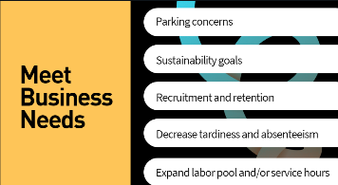
Notes: ____________________________________________________
__________________________________________________________
__________________________________________________________
__________________________________________________________
__________________________________________________________

How can commute trip reduction programs help your business needs? What issues are important to your company? Are there concerns about parking, meeting sustainability goals, recruitment and retention of employees, tardiness and absenteeism or does your business want to expand the labor pool or service hours?

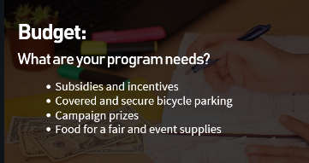
Slide 9:
Notes: ____________________________________________________
__________________________________________________________
__________________________________________________________
__________________________________________________________
__________________________________________________________
Let’s discuss how to request a budget. Begin by outlining what the budget will cover such as transit and vanpool subsidies, carpool start-up incentives, bike parking and a fix-a-flat tire station. And don’t forget about campaigns and event supplies.

Slide 10:
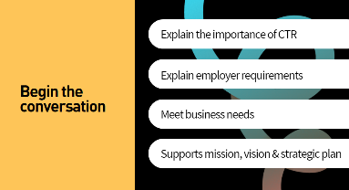
Notes: ____________________________________________________
__________________________________________________________
__________________________________________________________
__________________________________________________________
__________________________________________________________

So how do you begin a conversation with management? Begin by explaining the importance of commute trip reduction and employer requirements. Identify business needs that commute trip reduction can address. How does commute trip reduction fit into your company’s mission, vision and strategic plan?

Slide 11:
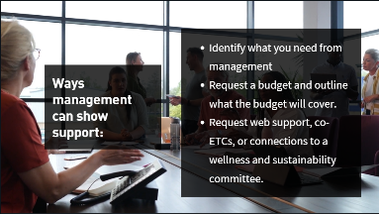
Notes: ____________________________________________________
__________________________________________________________
__________________________________________________________
__________________________________________________________
__________________________________________________________

Identify what you need from management and be prepared to request a budget and outline what the budget will cover. Request other resources such as web support, Co-Employee Transportation Coordinators, or to be connected to wellness and sustainability committees.

Slide 12:
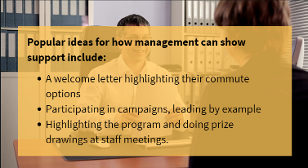
Notes: ____________________________________________________
__________________________________________________________
__________________________________________________________
__________________________________________________________
__________________________________________________________

Popular ideas for how management can show support include:
- A welcome letter that highlights sustainable commuting
- Participating in campaigns
- And mentioning program services or drawing prize winners at staff meetings.

Slide 13:
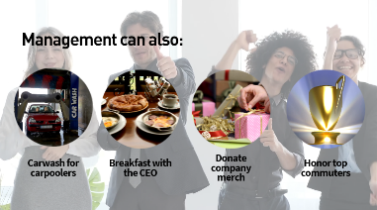
Notes: ____________________________________________________
__________________________________________________________
__________________________________________________________
__________________________________________________________
__________________________________________________________

Some fun ways that managers can promote sustainable commutes include free car washes for carpoolers, breakfast with the CEO, donating company merchandise for a prize drawing and congratulating sustainable commuters at a staff meeting.

Slide 14:
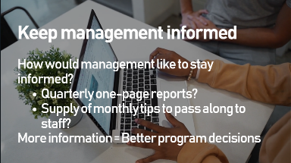
Notes: ____________________________________________________
__________________________________________________________
__________________________________________________________
__________________________________________________________
__________________________________________________________

Keep management informed about your program. Ask managers how they would like to stay informed. Would they like to receive quarterly one-page reports? How about supplying a monthly tips and information for them to pass along to staff.

Slide 15:
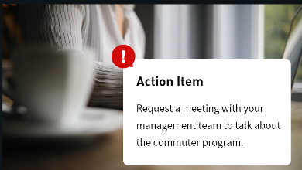
Notes: ____________________________________________________
__________________________________________________________
__________________________________________________________
__________________________________________________________
__________________________________________________________

Music

Slide 16:
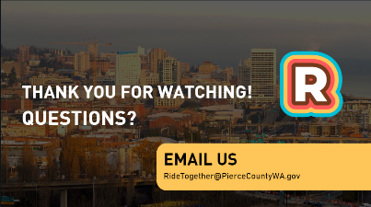
Notes: ____________________________________________________
__________________________________________________________
__________________________________________________________
__________________________________________________________
__________________________________________________________

Music

