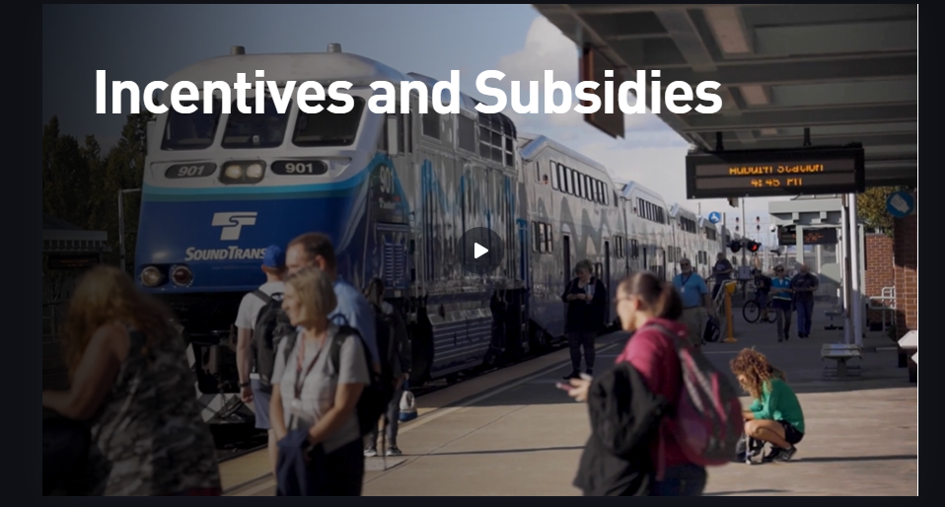
Incentives and subsidies provided by your employer can be a boost to help employees switch to sustainable transportation and help recognize the work of employees that do take sustainable transportation. Let’s talk about what kinds of incentives and subsidies employers can use so you can find what is right for your worksite.
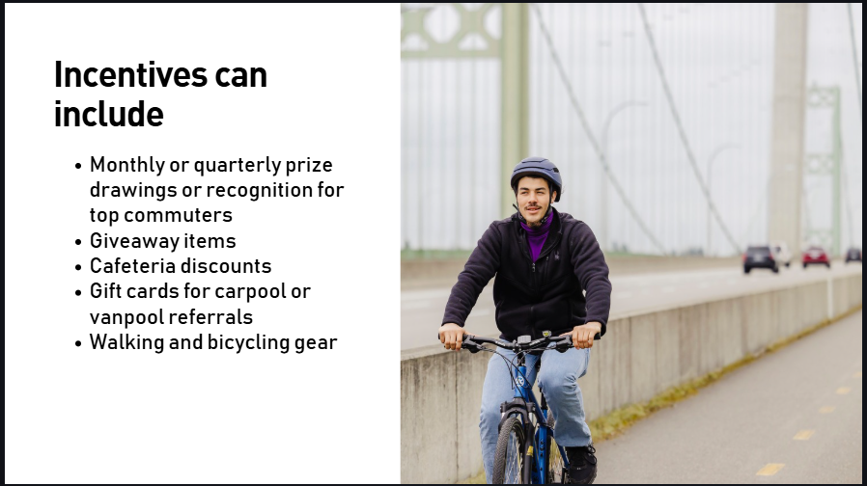
Incentives are rewards gifted one time or periodically to make it more enticing for employees to use sustainable modes.
Incentives can include, but aren’t limited to:
- Monthly or quarterly Prize drawings or recognition for top commuters
- Giveaway items
- Cafeteria discounts
- Gift cards for carpool or vanpool referrals
- Providing walking and bicycling gear
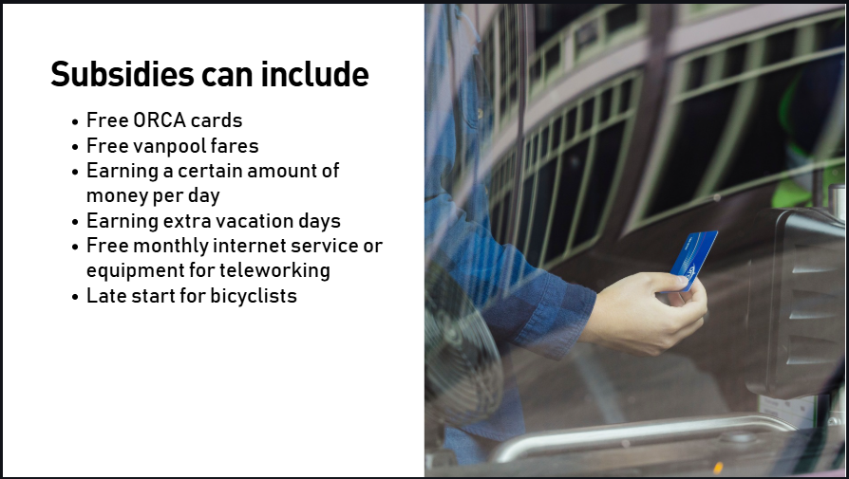
Subsidies are regularly provided and help make it easier for an employee to take sustainable modes.
Subsidies can include, but are not limited to
Free ORCA Cards. Your employer can purchase ORCA Passport products for a bulk discount on ORCA cards to provide to employees.
Paying employees’ vanpool fares. You can chose to subsidize entire or partial vanpool or transit services.
Allowing employees to earn a dollar amount per day for taking sustainable transportation
Earning time off like extra vacation days if an employee consistently uses sustainable transportation
Paying for monthly internet service or work from home equipment for teleworking.
Late start for bicyclists

Your employer can also benefit from sustainable transportation subsidies and incentives. For example, depending on the location of your worksite, your employer may actually save money on parking costs by reducing the need for employee parking.
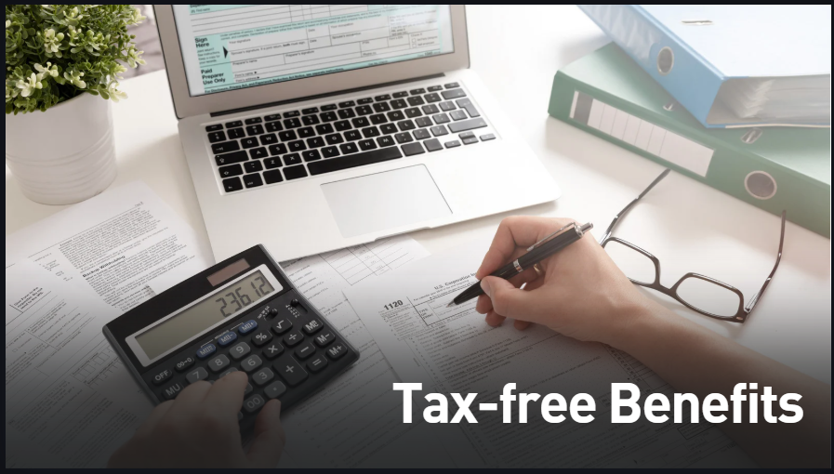
Additionally, transit or vanpool subsidies are tax-free fringe benefits which means that it is tax free income for both the employer and employee. A cash subsidy for other modes is considered taxable income, though. Consult with a tax professional on the best way to manage your program.
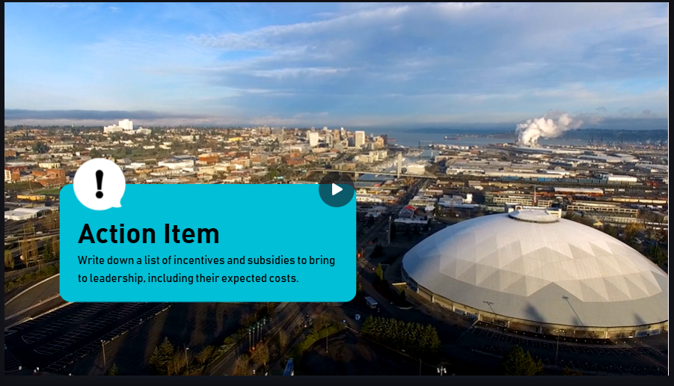
Action item:
Take some time to write down a list of subsidies and incentives that would work well at your worksite to bring to leadership, including their expected costs. Think about how you can gather input from your coworkers on what incentives and subsidies they would like to receive most.

