Marketing Your Program
Voiceover Script

Slide 1:
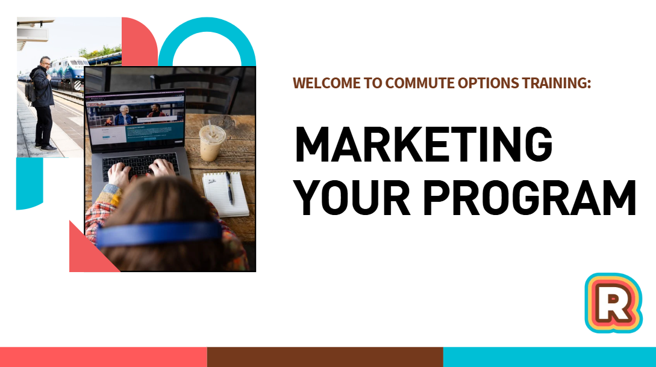
Music

Slide 2:
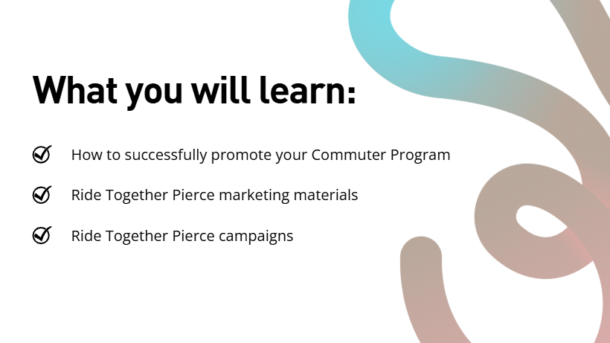
In this training, we will cover strategies to successfully promote your commuter program, and the Ride Together Pierce marketing materials and campaigns that can help you along the way.

Slide 3:
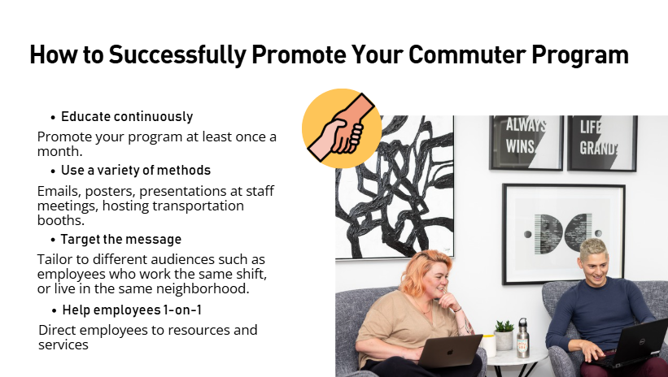

There are a few strategies we recommend for you to run a successful commuter program.
- Educate continuously: Promote your program to employees at least once a month. People’s priorities and schedules change often, so it’s important to catch people at the right time.
- Use a variety of methods: You can send an email, hang posters, give a presentation at a staff meeting, host a transportation booth at a fair, and more.
- Target the message: Tailor to different audiences such as employees who work the same shift or live in the same neighborhood. They are likely to have similar commutes.
- Help employees 1-on-1: If people need help finding a carpool buddy or looking up transit schedules, know where you can direct them to, such as the Ride Together Pierce website, or a transit agency website.
Slide 4:
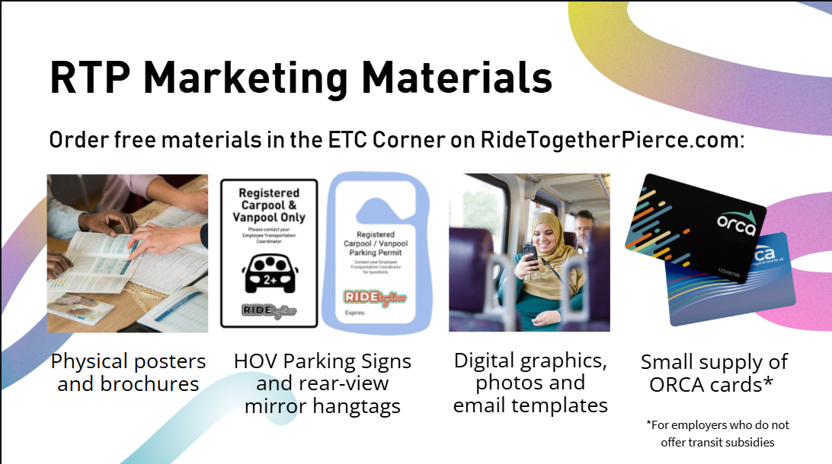

Employee Transportation Coordinators can access a host of free marketing materials in the ETC Corner of the Ride Together Pierce website. You can order physical items such as brochures, bike maps, stickers, HOV parking signs and rear-view mirror hangtags. We also offer digital products such as email templates, posters, web graphics, and a photo library. Some employers can also order ORCA transit cards to incentivize program participation.

Slide 5:

It’s time for a pop quiz.

Slide 6:
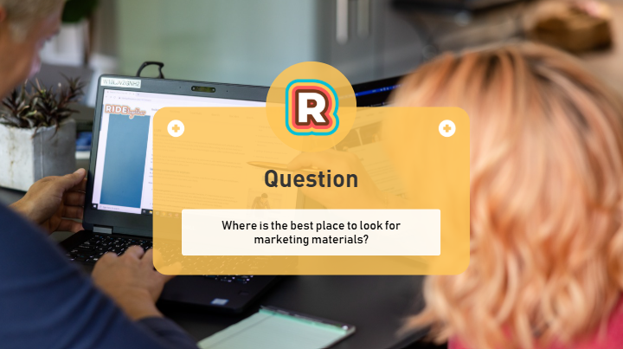
Where is the best place to look for marketing materials?

Slide 7:
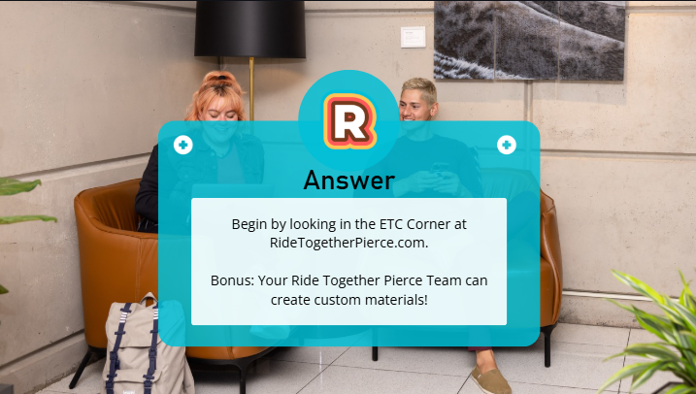
You can find a large variety of items on the ETC Corner on RideTogetherPierce.com.
If you cannot find what you are looking for, reach out to us. We can help you find what you need or make custom materials.

Slide 8:
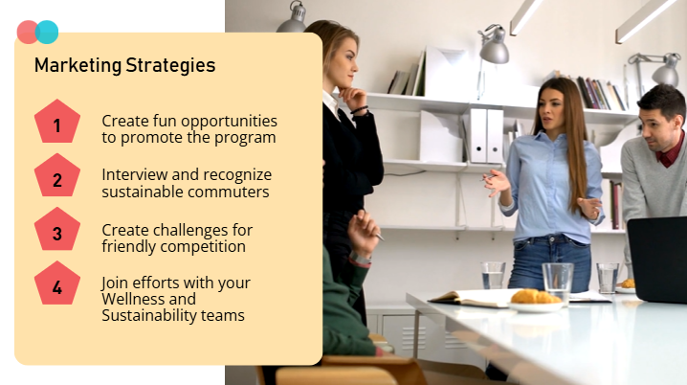
Here are some marketing strategies for you to consider:
- Create fun opportunities to promote the program. Quiz employees at staff meetings and hand out treats or host a carpool ridematching event.
- Recognize sustainable commuters. Ask employees about their sustainable commutes and show coworkers how easy it can be. Find example commuter interviews by searching the Ride Together website.
- Create challenges for friendly competition. You can host a prized challenge to see which employees try a new mode of transportation, or walk or bike the most. These can be small prizes like snacks, company merch or coffee gift cards.
- Lastly, you can share the load by collaborating with your Wellness or Sustainability teams.

Slide 9:
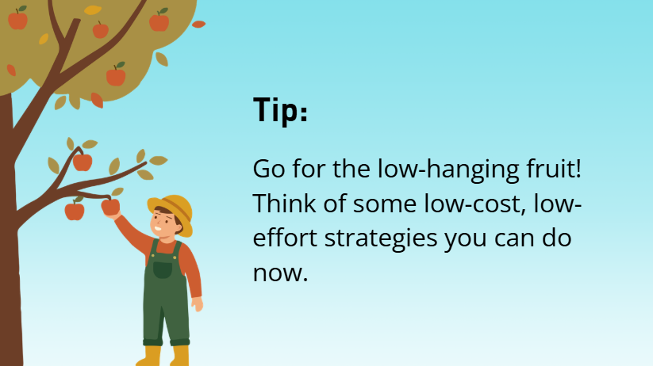
Can you think of any low-barrier ideas to create excitement for your commuter program?

Slide 11:
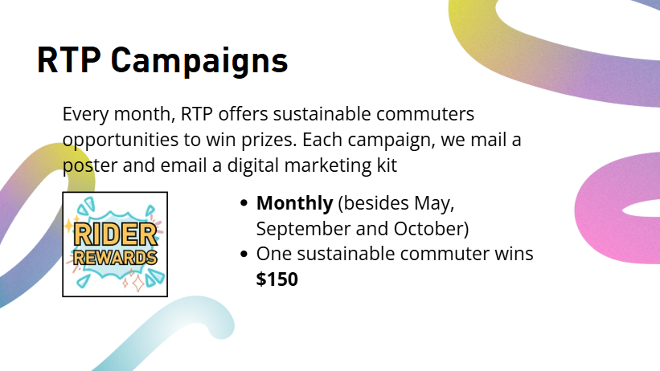
Now let’s talk about Ride Together Pierce campaigns that can help generate interest. Every month, RTP offers sustainable commuters opportunities to win prizes through “campaigns”. Every time there is a new campaign, we mail a poster and email a digital marketing kit.
- Most months, we have “Rider Rewards” which awards one lucky sustainable commuter with $150
- In May, we host the “Bike Everywhere Challenge” which awards several bicyclists with $20 to $50 awards, and top bike teams win a pizza party.
- In September, we host “Find Your Commute Buddy,” where users who update their profile and or commute information on the trip calendar can enter to win $25.
- Lastly, in October, we participate in the statewide “Switch Your Trips” campaign which awards sustainable commuters with prizes ranging from $50 to $1,500!

Slide 13:
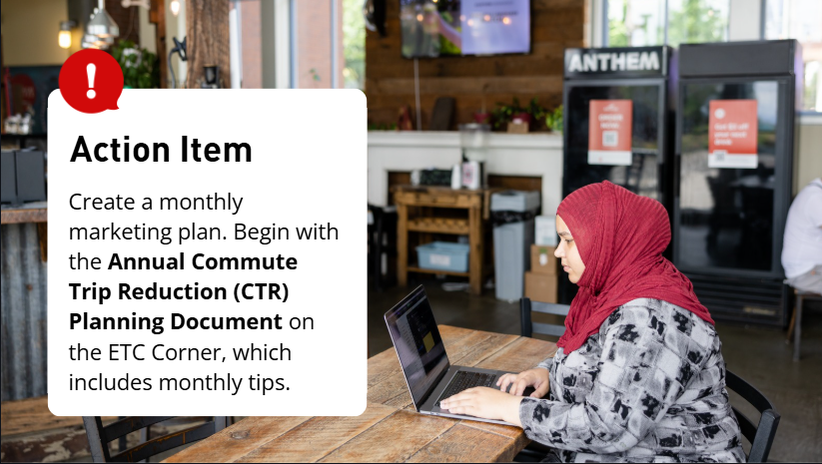
Action item: Develop a monthly marketing plan. Think about what benefits, services and campaigns you want to promote. Is there someone who can help you, such as Human Resources, the Marketing team, or Wellness team? To get you started, check out our “Annual Commute Trip Reduction Planning Document” which has monthly tips and ideas.

