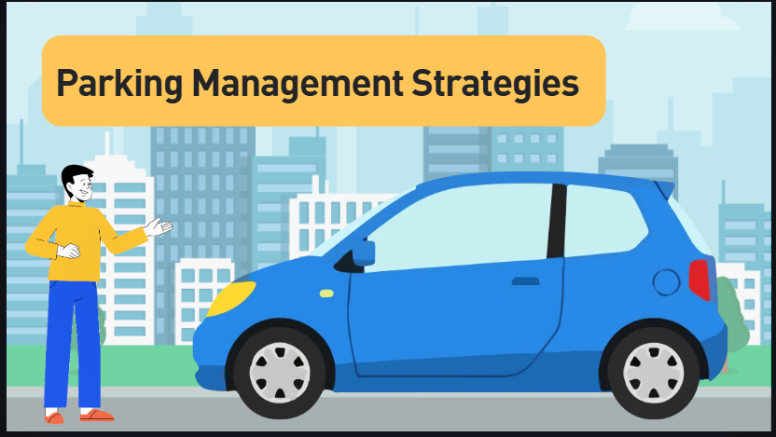
Parking management is a tool that can help reduce drive alone commuters.
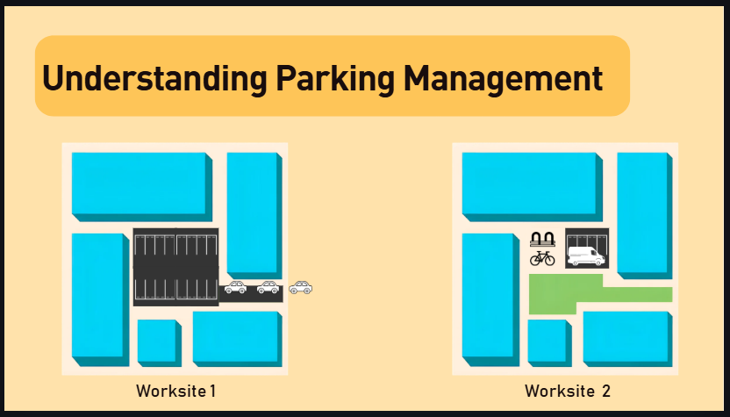
Let’s look at an example to understand the basic principles of parking management. Here are two examples of worksites. Worksite one has abundant and free parking. It is easy to park, so it is easy to drive alone.
Worksite two has limited parking spaces which you have to pay for. The bike lockers and priority parking for carpools make it easiest and cheapest to bike or carpool with others.
This is the foundation of parking management.

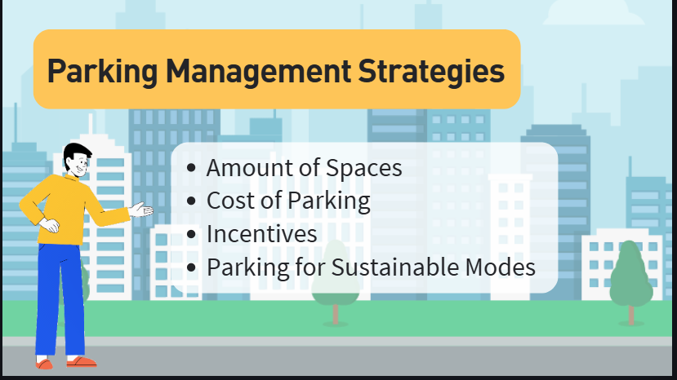
There are many strategies used to balance the supply and demand for parking to make sustainable modes more attractive than driving alone. By altering the amount of spaces, cost of parking, offering incentives, and offering parking for sustainable modes, your employer can encourage employees to take a sustainable mode and even save money.
Let’s talk about strategies so you can pitch some ideas to management.
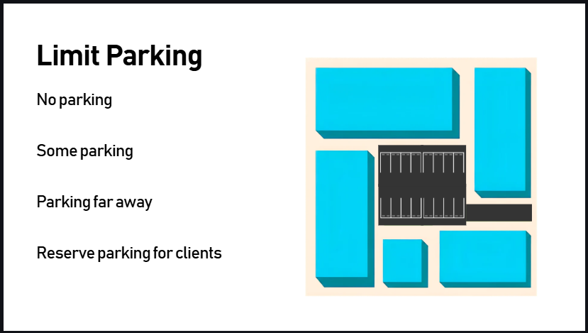
Not offer parking, limit the number of spaces, or change the location of parking.
- Depending on your worksite and how your employer offers parking, it may be possible to not offer parking, reduce the number of spaces, offer parking a little further away, or reserve parking for clients instead of employees
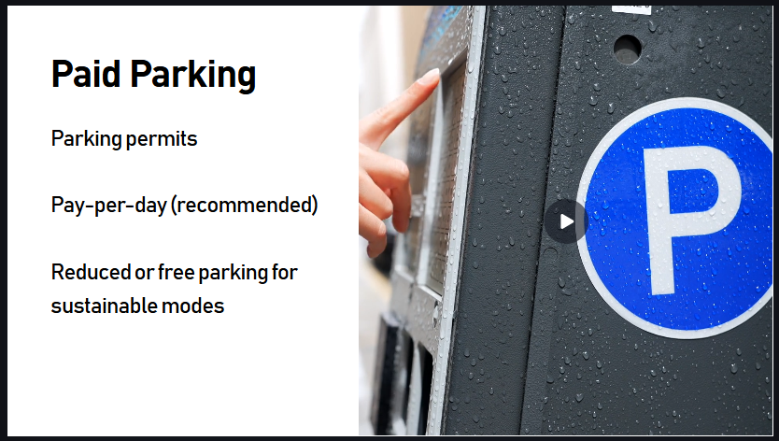
Employers can charge for parking
- By requiring paid permits or pay per day parking, employers can encourage alternative methods of getting to work. One option is to provide free or discounted parking for carpool and vanpool vehicles.
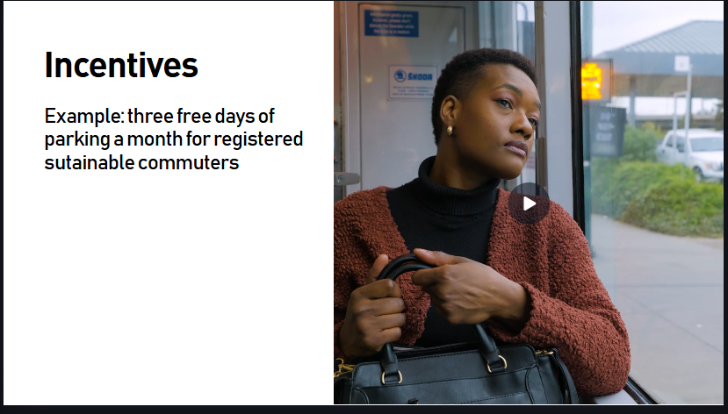
Employers can offer incentives
- One example of an incentive your employer can offer is 3 free days of parking a month for registered sustainable commuters. This cost saving incentive could help employees switch from driving alone every day to just a few days a month.
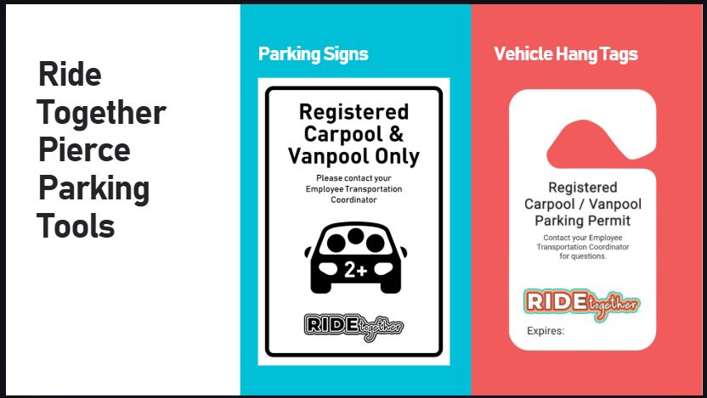
Offering parking for vanpools, carpools, and bikes
- By offering high quality and free or discounted parking for sustainable modes, it is more attractive for employees to take these modes.
- To offer priority parking for carpools or vanpools, reserve a few spaces in the parking lot that are close to the building so carpool and vanpool riders always have parking that is convenient. Also consider making these spots free or discounted.
- Ride Together Pierce offers free signs and car hang tag permits for registered carpools and vanpools. You can order the signs and hang tags from the product order form in the ETC corner of the Ride Together Pierce website.
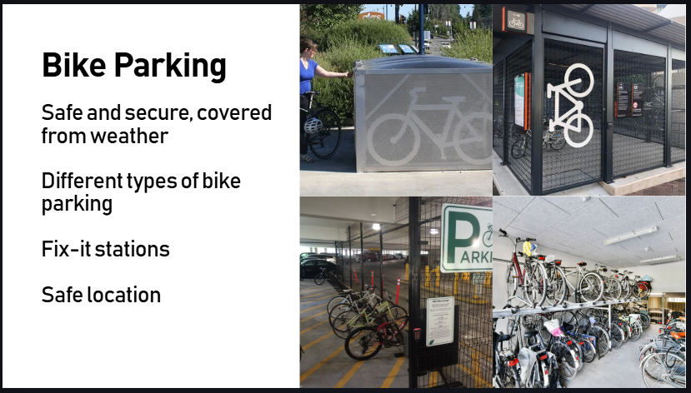
- Bike parking
- Employers can also offer bike parking that is safe, secure, and covered to protect from the weather. There are several options for secure bike parking depending on worksite conditions and employee needs.
- Bike parking can be bike lockers, bike cages, a fenced corner of the parking garage, or an unused room in the building. Employers should consider installing a fix-it station for bicyclists to fix flat tires and make minor adjustments. Employers should also take safety into consideration when choosing a bike parking location so it has adequate lighting, vegetation is cut back, and there are no hazards on the path that would make it difficult to bike to.

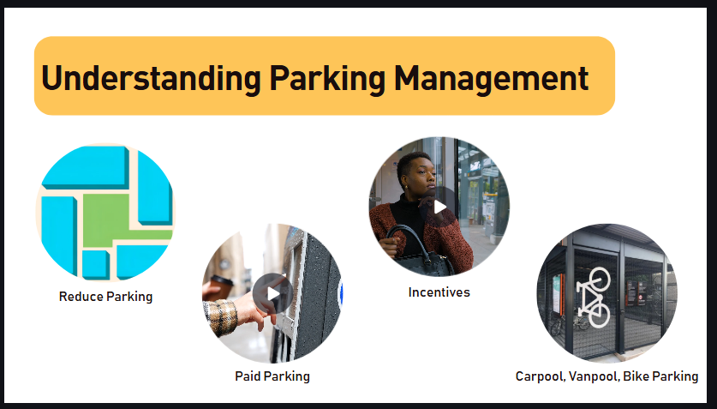
Let’s review the strategies:
Offering no or limited parking
Charging for parking
Offering incentives
Offering high quality, priority parking for vanpools, carpools, and bikes
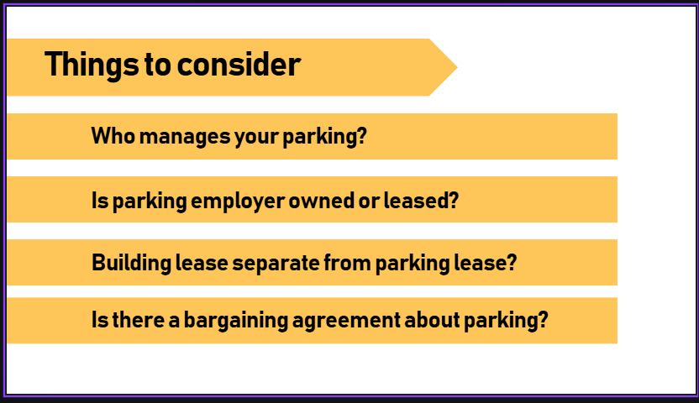
Things to consider when making your parking management strategy
- Who manages your parking
- Is parking owned by your employer or leased
- Your worksite parking lease may be part of your building lease. It may be possible to unbundle these for more flexibility to control parking supply
- If there is a bargaining unit for employees, is parking a negotiated item? This may restrict how you can control parking supply.

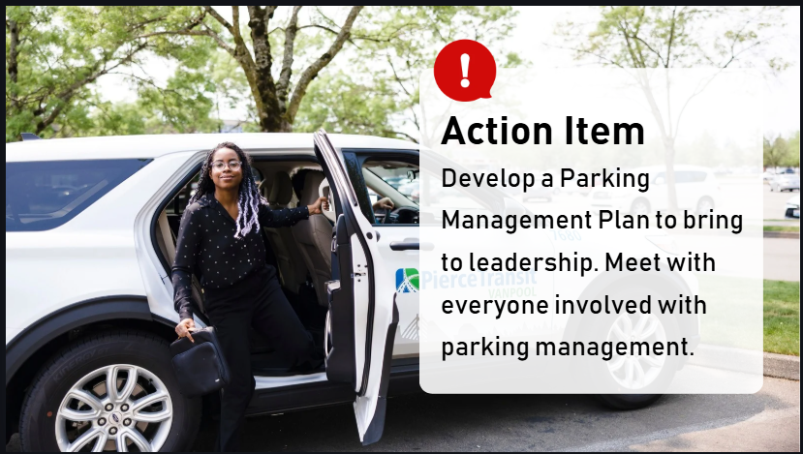
Action item: Develop a parking management plan to bring to leadership. Make sure to meet with everyone involved with parking management and discuss desired outcomes for the commute trip reduction at your worksite.

