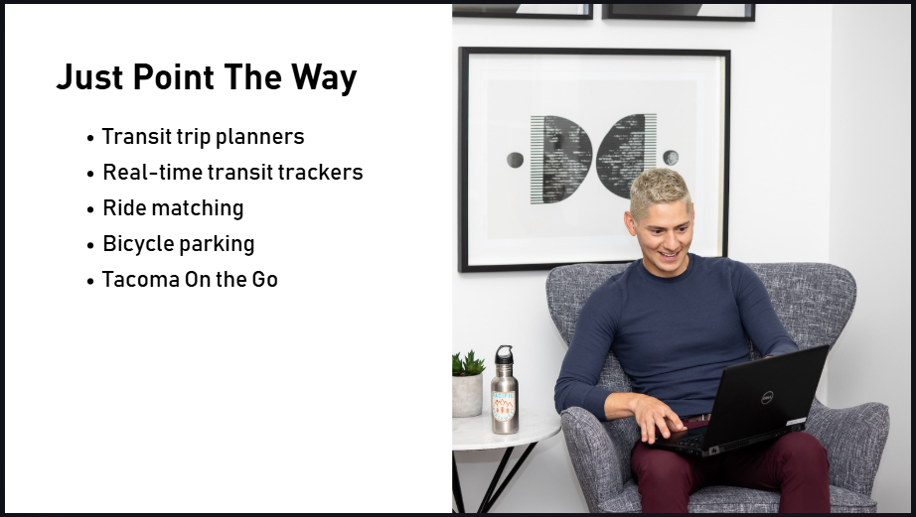
As the Employee Transportation Coordinator, you do not need to become an expert on every commuter resource. You just need to be able to point the way to available resources like transit planners and bus trackers, ride matching, and bike parking.
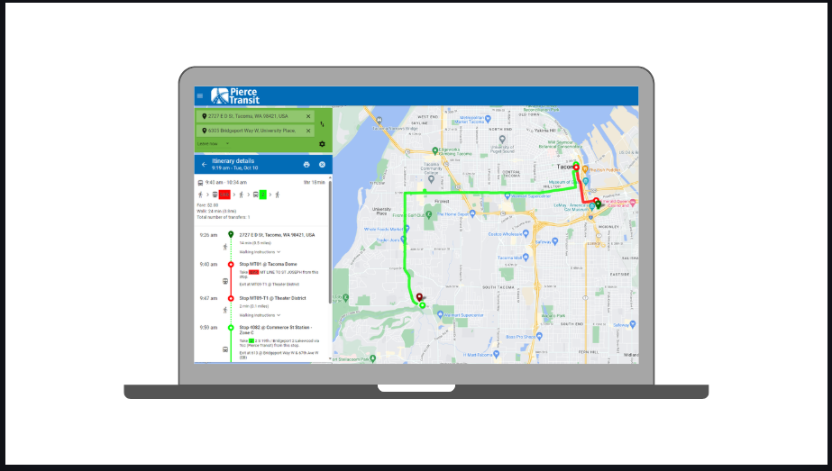
Employees can plan their bus trip at PierceTransit.org. The website has route maps and schedules, but the easiest way to plan a trip is with the Plan Your Trip tool. To begin, they Employees just need to enter their starting and ending location as well as the time and date of the trip. Then, the tool will show a route map and trip options and fares. Their website also has route maps and schedules.
Customer service is also available to help plan trips.

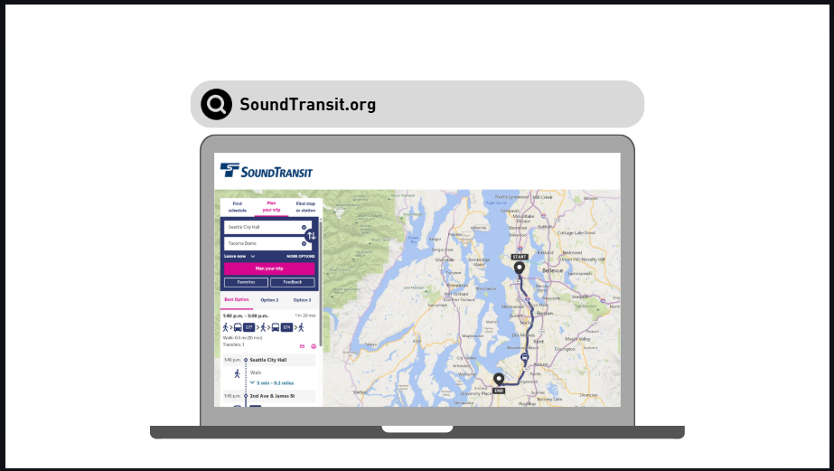
Employees can plan trips on Sound Transit buses, Link light rail, and the Sounder train on SoundTransit.org. Similar to Piercetransit.org, the website has information on transit schedules and stations as well as a trip planning tool. Employees can enter their beginning and end locations and time and date of trip. The tool will show a route map and trip options.
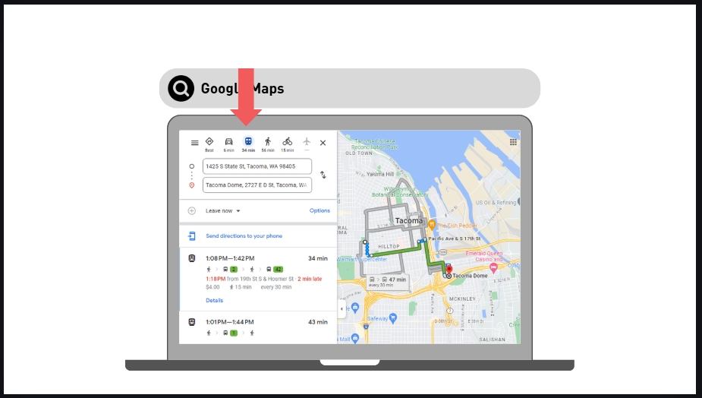
Google Maps is also popular option for finding routes. Employees can enter a start and end location as well as time and date and click the transit icon to show transit route options. Google Maps is great for planning an immediate trip because it will show you when the next bus is scheduled and can use your current location.
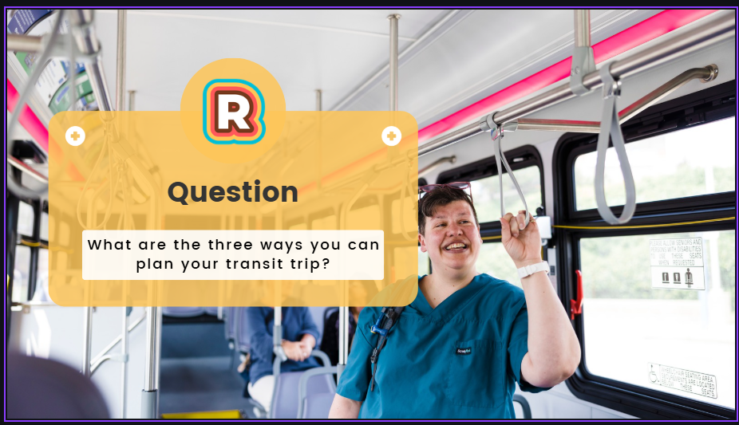
Pop Quiz!
What are the three ways you can plan your transit trip?
The correct answer is PierceTransit.org, SoundTransit.org, Google Maps.
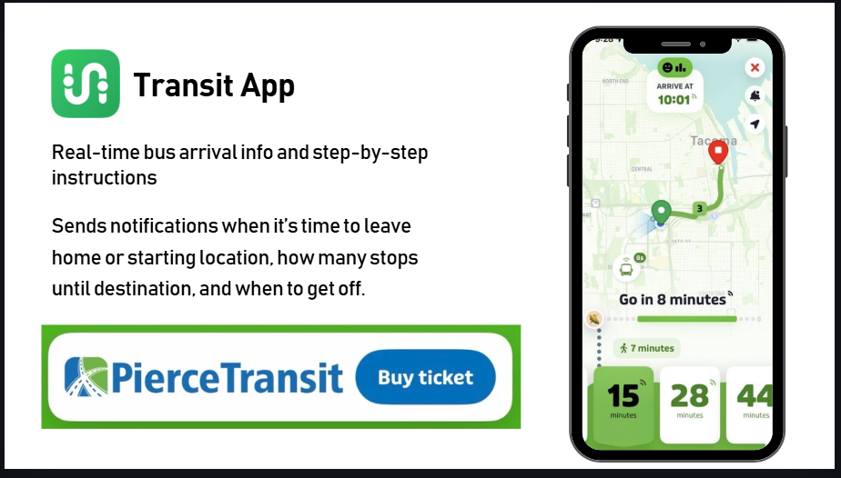
To track where a bus actively is, employees can use the Transit app. They enter their destination, choose their route, and the app will track their bus or train live so they know exactly when to leave. It provides step by step guidance with notifications telling them when they should leave your home or starting location, how many stops until their destination, and when to get off. They can also purchase Pierce Transit fare through the app.
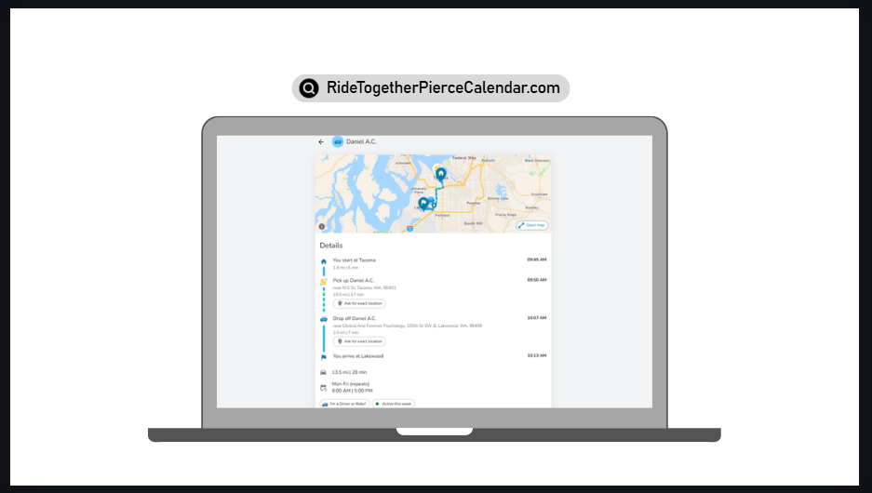
Encourage your employees to look for carpools and vanpools through the Ride Together Pierce Trip Calendar. Once they have entered their work and home addresses under account settings, they can use the Pools section of the calendar to find people to carpool with or a vanpool to join. The tool will show the route of the carpool or vanpool and employees can reach out to other users directly through the platform. For privacy, the tool does not show users’ exact addresses.

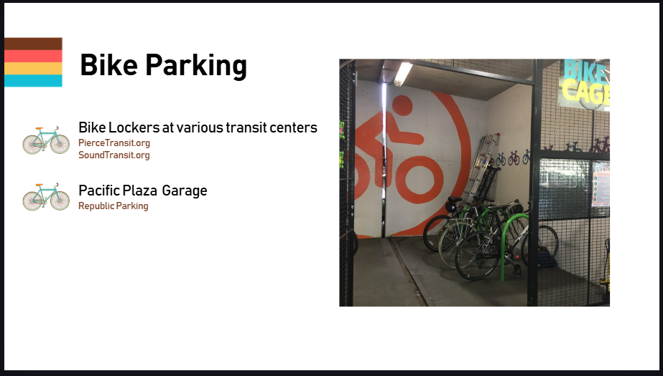
There are options for employees to securely park their bike during the day in Pierce County. Pierce Transit and Sound Transit have bike lockers available at many transit centers and park-and-rides in the county.

Republic Parking also has secure bike storage in the Pacific Plaza Garage in downtown Tacoma.

Visit their websites for more information.
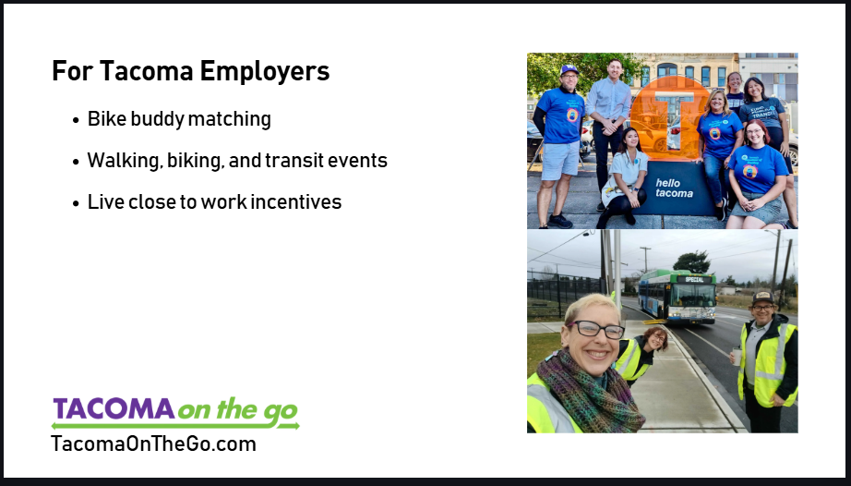
Tacoma on The Go is a transportation resource organization in Tacoma. They share resources like information and materials about sustainable transportation, they bring people together to learn and make connections, including walking, biking, and transit events. They advocate for safe mobility for all. And, they support CTR affected employers in Tacoma.
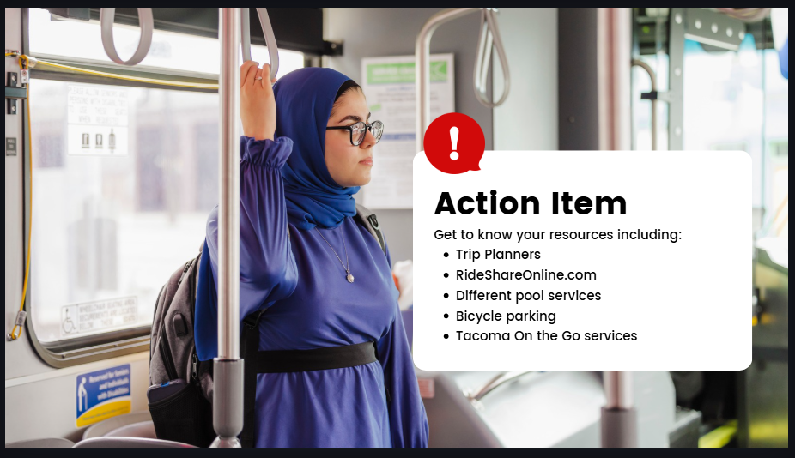
Take some time after this video to become familiar with planning transit trips, using the Transit app, Ride Matching, bike parking near your worksite, and Tacoma On the Go.

