Why Commute Trip Reduction
Voiceover Script

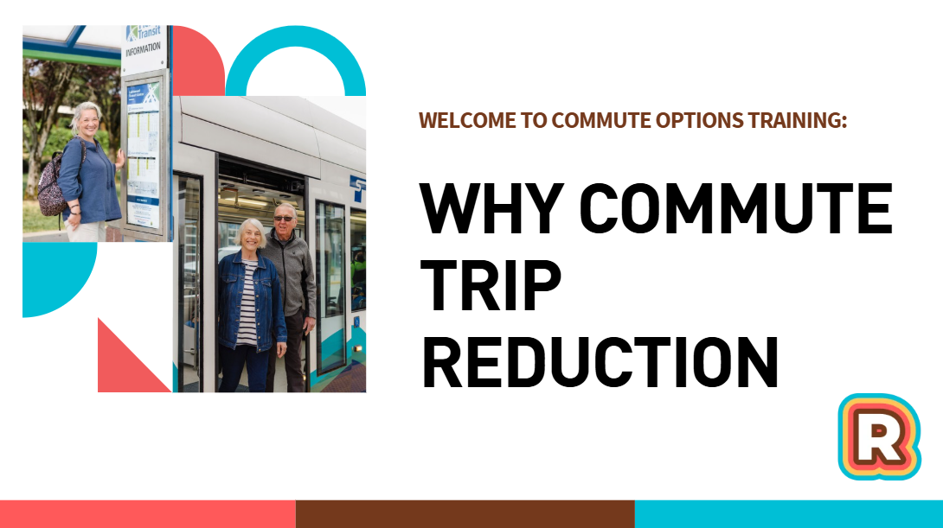
Music

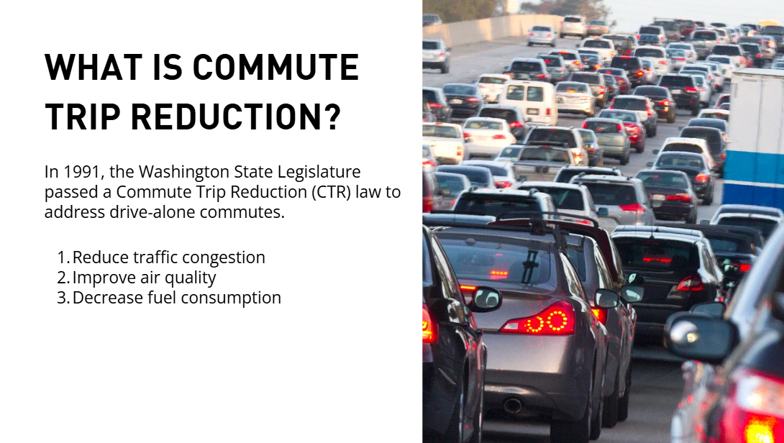
What is commute trip reduction? In 1991, the Washington State Legislature passed a Commute Trip Reduction law to address drive-alone commutes. The legislature’s goals were to Reduce traffic congestion, improve air quality, and decrease fuel consumption in Washington State.

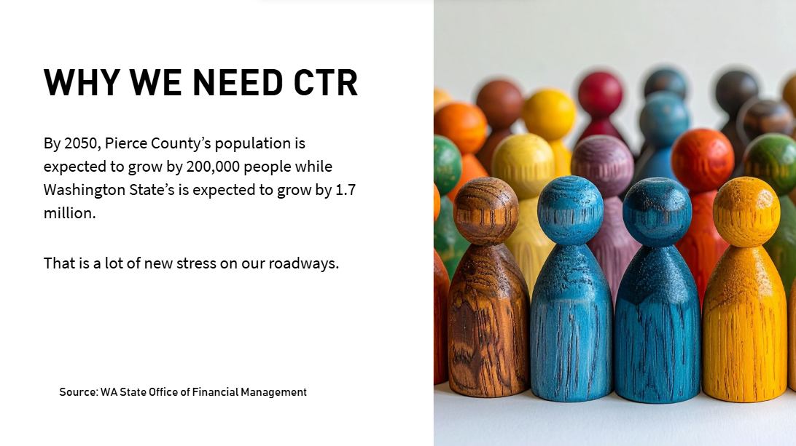
We need Commute Trip Reduction (or CTR) because by 2050, Pierce County’s population is expected to grow by 200,000 people while Washington State’s population is expected to grow by 1.7 million people. That is a lot of new stress on our already congested roadways.

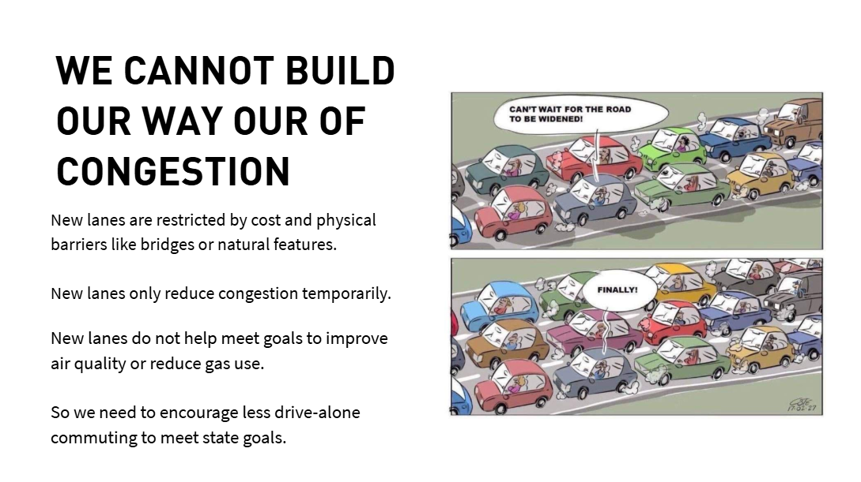
- CTR programs are important because we cannot build our way out of congestion. New lanes on our roads are restricted by high costs and physical barriers like bridges or natural features. Think of I-5 near the Nisqually Wildlife Refuge, for example.
- New lanes on our roads only reduce congestion temporarily before more people choose to drive, encouraged by the idea of less traffic.
- New lanes on our roads also do not help meet goals to improve air quality or reduce gas use. So, we need to encourage less drive-alone commuting to meet state goals

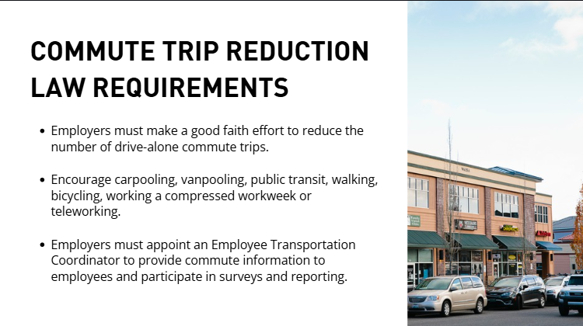
What are the requirements of the Commute Trip Reduction Law?
- Employers must make a good faith effort to reduce the number of drive-alone commute trips to their worksites.
- Employers must Encourage carpooling, vanpooling, public transit, walking, biking, working a compressed workweek or teleworking.
- Employers must appoint an Employee Transportation Coordinator to provide commute information to employees and participate in surveys and reporting.

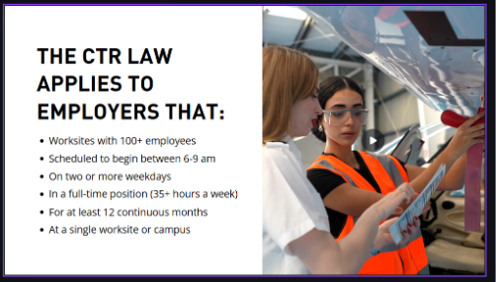
The CTR law applies to employers that have worksites with 100 or more employees, scheduled to begin between 6-9 am, on two or more weekdays, in a full-time position (35+ hours a week), for at least 12 continuous months, at a single worksite or campus.


Pop quiz!

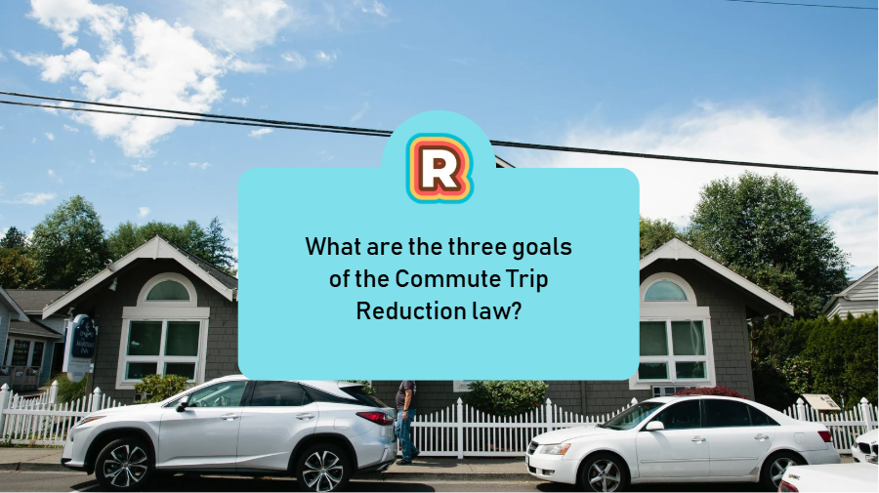
What are the three goals of the Commute Trip Reduction law?

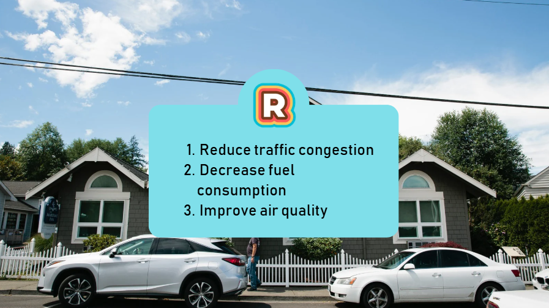
The correct answers are: Reduce traffic congestion, decrease fuel consumption, and improve air quality.

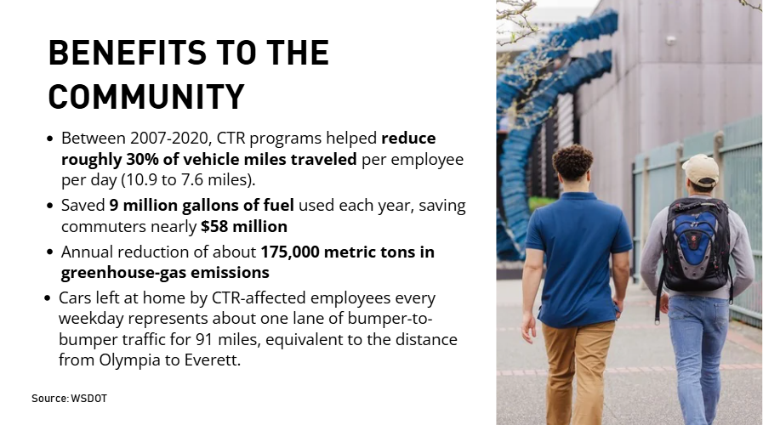
Employer’s work on commute trip reduction has many benefits to the Pierce County community!
- In Washington State, CTR programs have helped reduce vehicle miles traveled by roughly 30% per employee. That has saved 9 million gallons of gas and $58 million dollars each year.
- This also leads to an annual reduction of about 175,000 metric tons in greenhouse-gas emissions.
- Cars left at home by CTR-affected employees every weekday equals about one lane of bumper-to-bumper traffic from Olympia to Everett

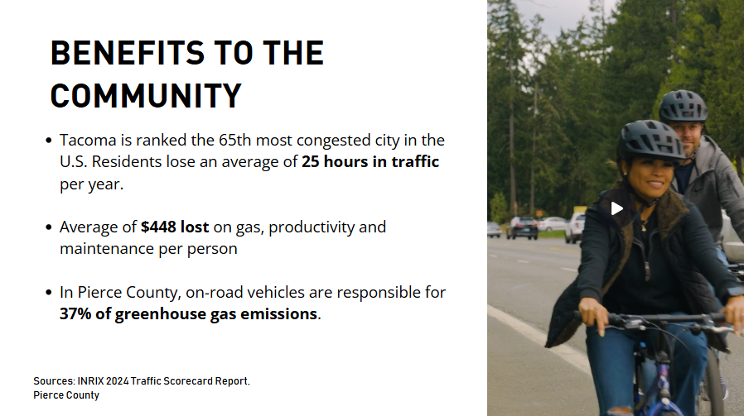
- This progress is important here because Tacoma is ranked the 65th most congested city in the US with an average of 25 hours in stuck in traffic per year per person.
- Tacoma residents spend an average of $448 for gas, lost productivity and increased maintenance each year.
- In Pierce County, on-road vehicles are responsible for 37% of greenhouse gas emissions.

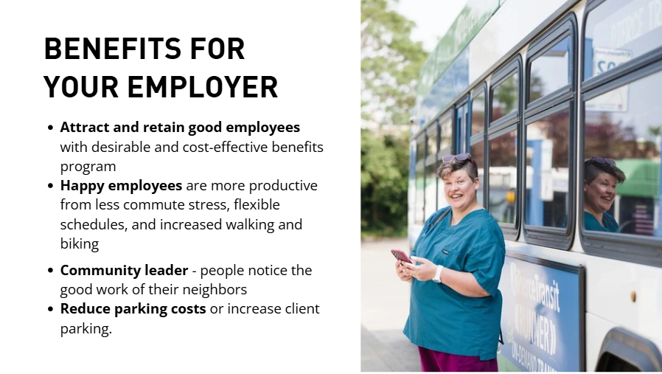
CTR programs are good for employers too:
- They can help attract and retain good employees by providing desirable and cost-effective benefits programs.
- CTR programs can make employees happier, so they are more productive from less commute stress, flexible schedules, and increased walking and biking.
- They can help your employer become a community leader - people notice the good work of their neighbors.
- It can also reduce parking costs for the employer or increase client parking availability.


Pause the video for a few minutes to write down how a sustainable commute program can help your employer’s bottom line.

