Commute Modes
Voiceover Script

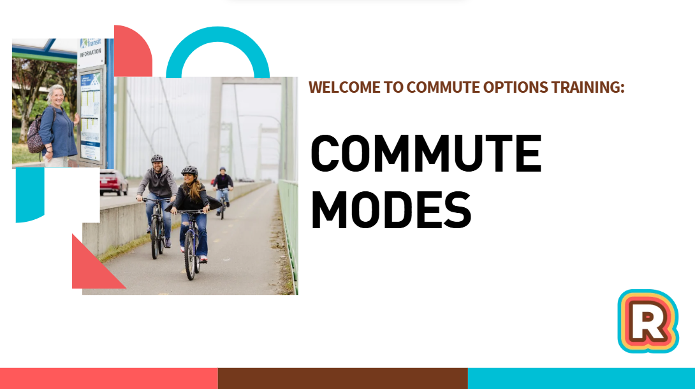
Music
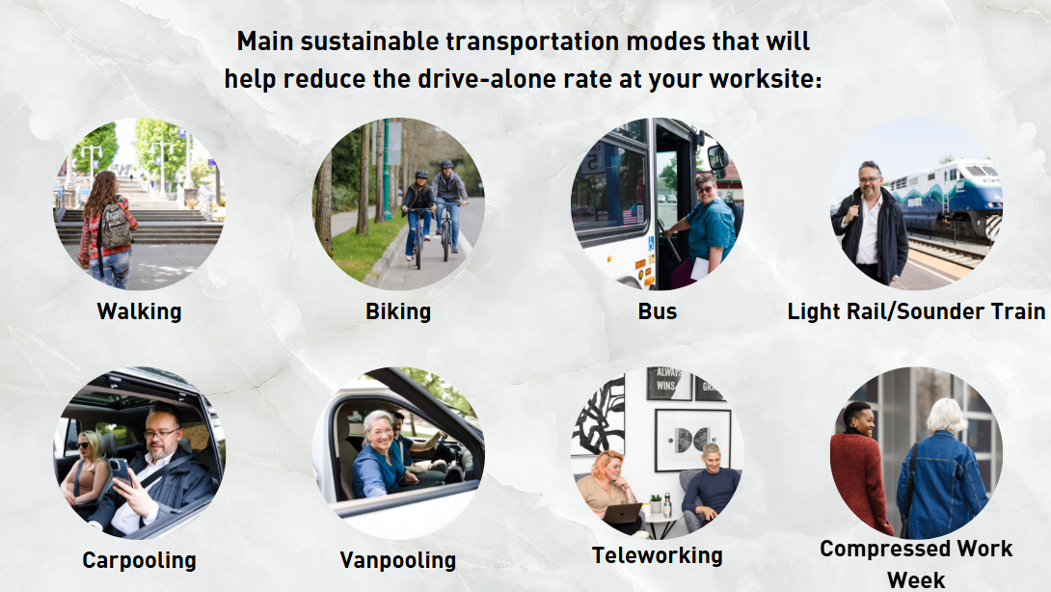
The main sustainable transportation modes that will help reduce the drive-alone rate at your worksite are walking, biking, taking a bus, taking a train like light rail or sounder, carpooling, vanpooling, teleworking, and compressed work week.
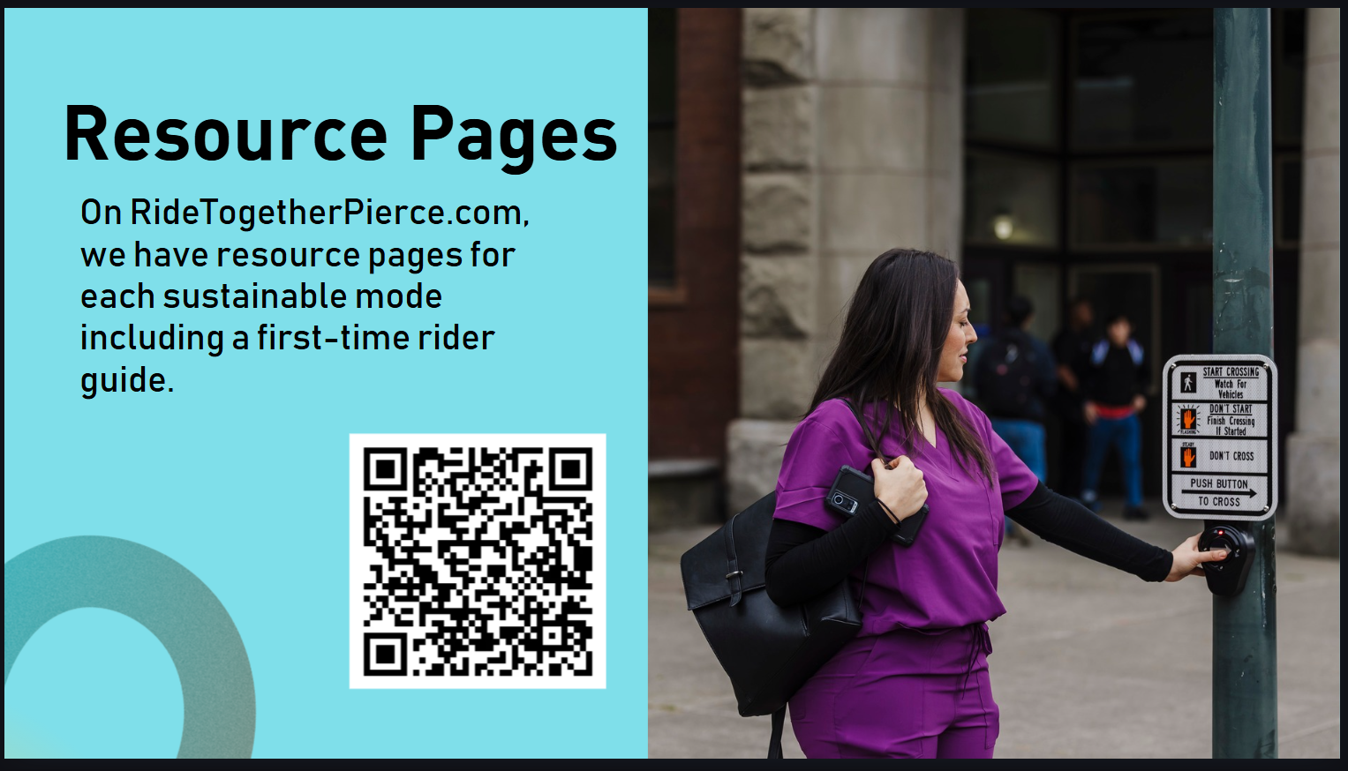
RideTogetherPierce.com has resource pages for these sustainable modes including a first-time rider guide for each one. These guides lay out the basics including route planning, safety, paying fares, and much more.
Scan the QR code to view the list of modes and navigate to their resource pages. You will see URLs throughout this presentation for mode-specific pages. As well as this QR code again.
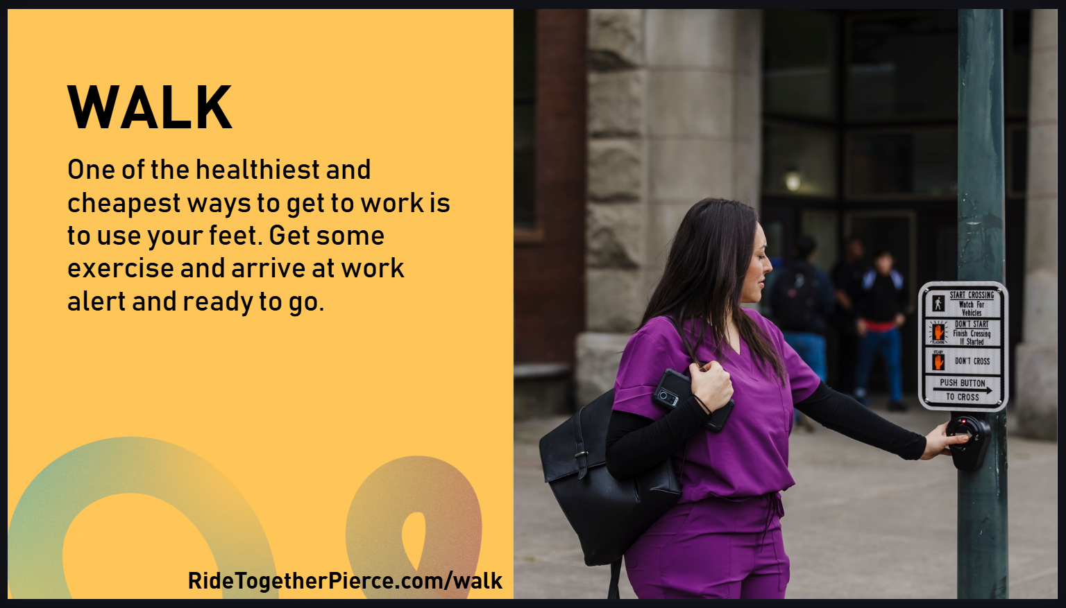
Let’s go over the modes.
Walking and rolling
One of the healthiest and cheapest ways to get to work is to walk or roll. Get some exercise and arrive at work alert and ready to go.
Things to consider at your worksite: Are there sidewalks or trails leading to your worksite? Create route maps to encourage staff to walk or roll to work.
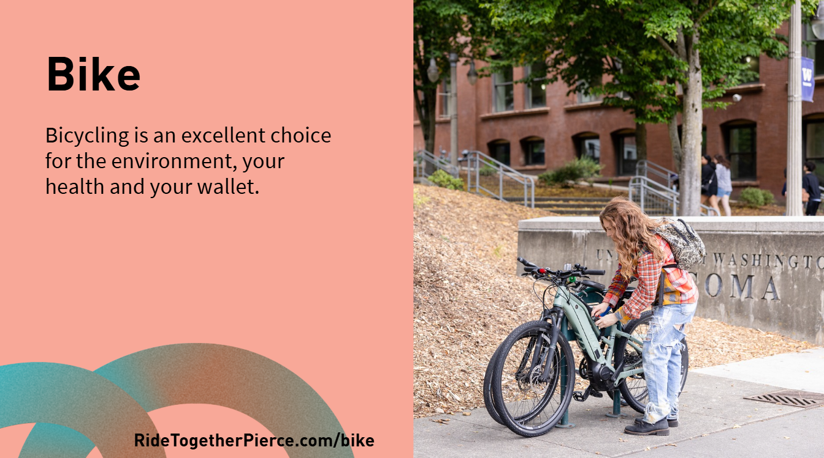
Biking
Bicycling is an excellent choice for the environment, your health and your wallet.
Things to consider: Are there bike lanes, sidewalks or trails leading to your workplace? Are there bike racks or storage for those who bike to work? Advertise this to staff!
Employees can also use a bike in combination with transit by biking to a transit center or bringing their bike on transit. Bikes can be brought on light rail, Sounder, and buses.
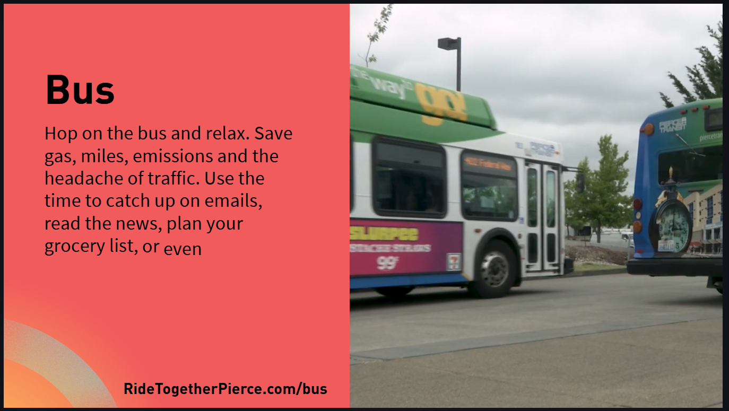
Bus
Ride the bus and save gas, miles, emissions and the headache of traffic. Use the time to catch up on emails, read the news, plan your grocery list, or even catch up on some sleep.
Things to consider: Are there any buses that come near your business? Create a map and list of buses your coworkers can ride to work
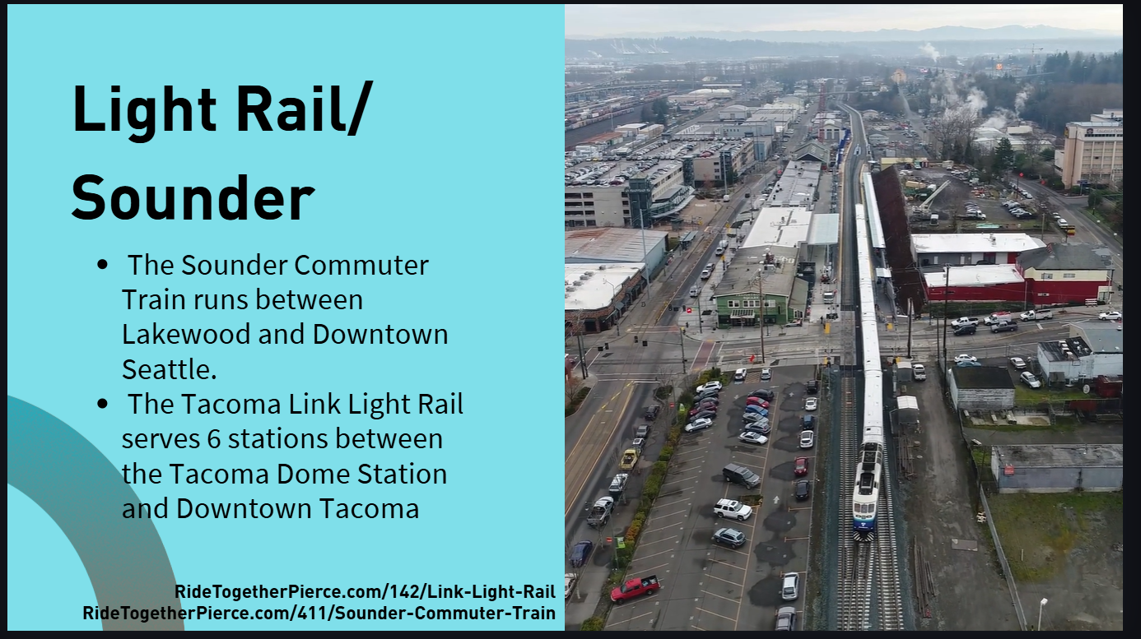
Link Light Rail and the Sounder
The Tacoma Link Light Rail serves 12 stations between the Tacoma Dome and St. Joseph Hospital.
The Sounder Commuter Train runs between Lakewood and Downtown Seattle on weekdays.
Things to consider: Are there stations near your worksite? Make a map of stations including connecting bus or bike routes.

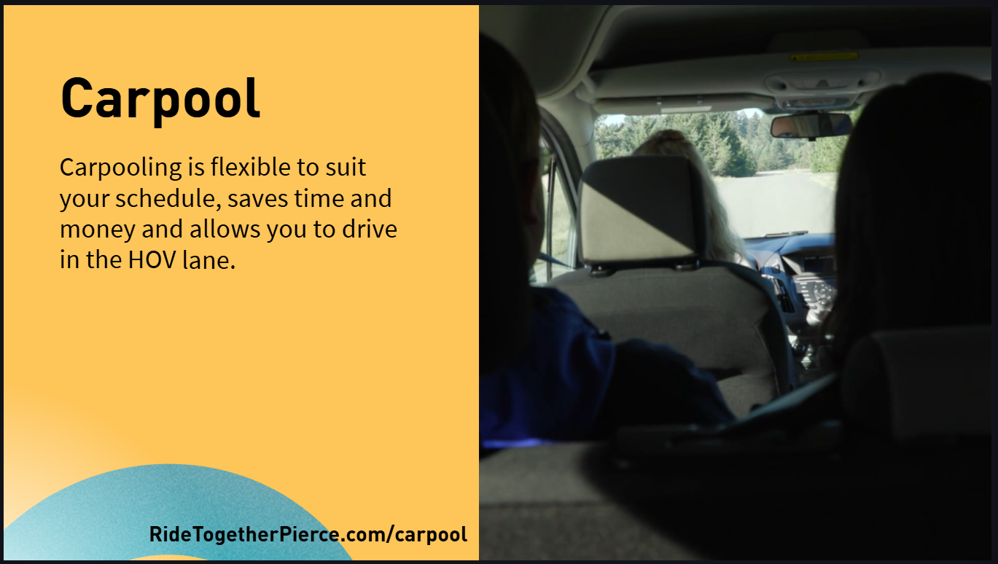
Carpool
Employees can carpool with coworkers or people riding similar routes. Carpooling can save time and money and allows you to drive in the HOV lane.
Things to consider: Use the Ride Together Pierce Trip Calendar to find people to carpool with. You can also use "Carpoolers Wanted" signs at your workplace to find a rider. The image on the right is an example. Fill out information about your commute and hang it up in the office so people can reach out to organize a carpool.

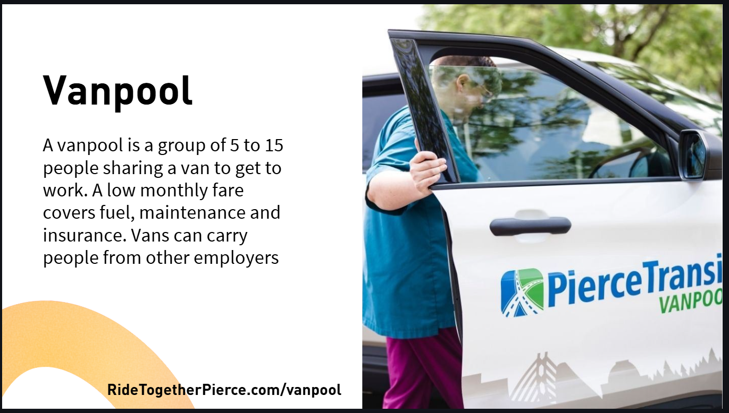
Vanpool
A vanpool is a group of 3 to 15 people sharing a van operated by a transit agency to get to work. A low monthly fare covers fuel, maintenance and insurance. Vans can carry people from other employers, as well. Employees can use Pierce Transit’s vanpool service, called Rideshare, to find existing vanpools or create a new one.
Things to consider: Work with your HR department to create an employee zip code map and see who could potentially form a vanpool.

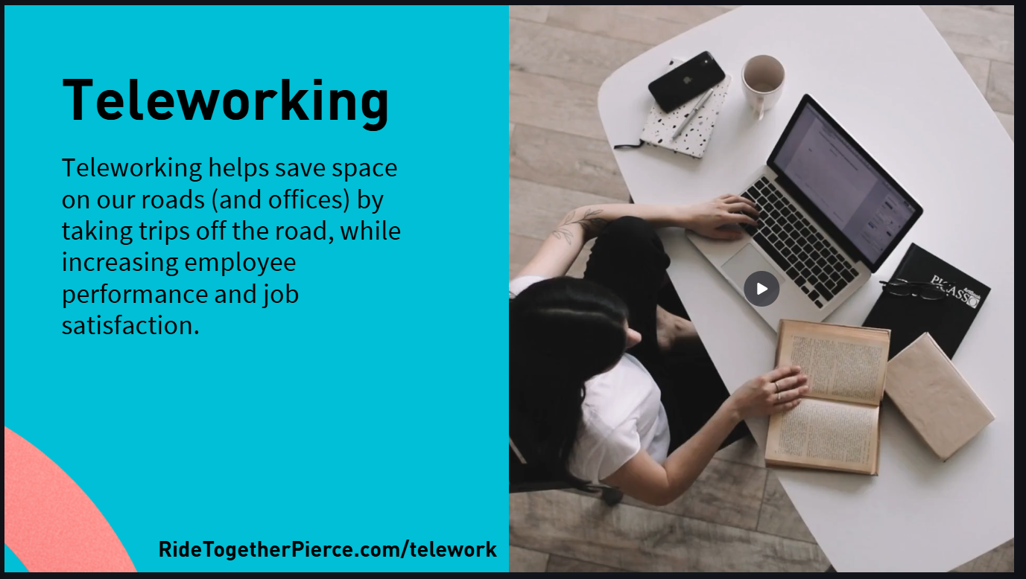
Teleworking
Teleworking helps save space on our roads (and offices) by taking trips off the road, while increasing employee performance and job satisfaction.
Things to consider: Use the Ride Together Pierce Telework Toolkit to understand the benefits of telework and how to implement successful telework policies at your workplace.
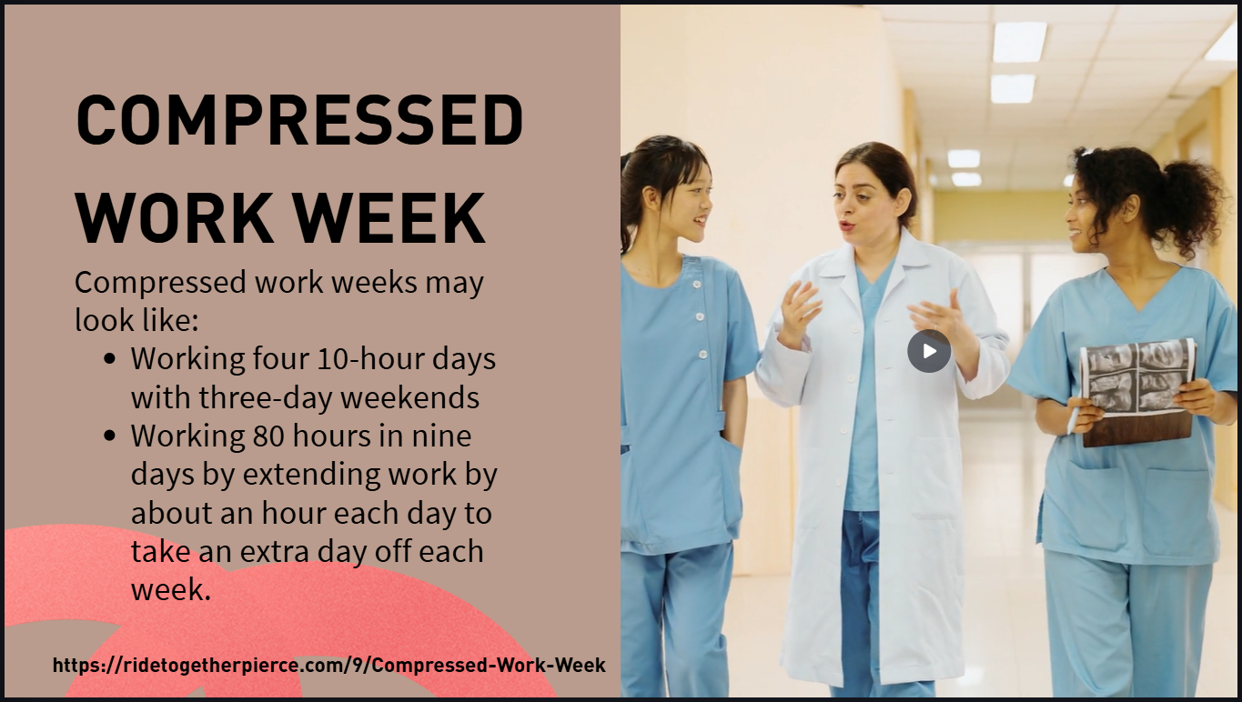
Compressed work week
There are many ways to have a compressed work week, but it may look like:
- Working four 10-hour days with three-day weekends often called 4 10s
- Working 80 hours in nine days by extending work by about an hour each day to take an extra day off each week. 9/80
Research compressed work week policies and see if this program would be a good fit for certain positions at your workplace.

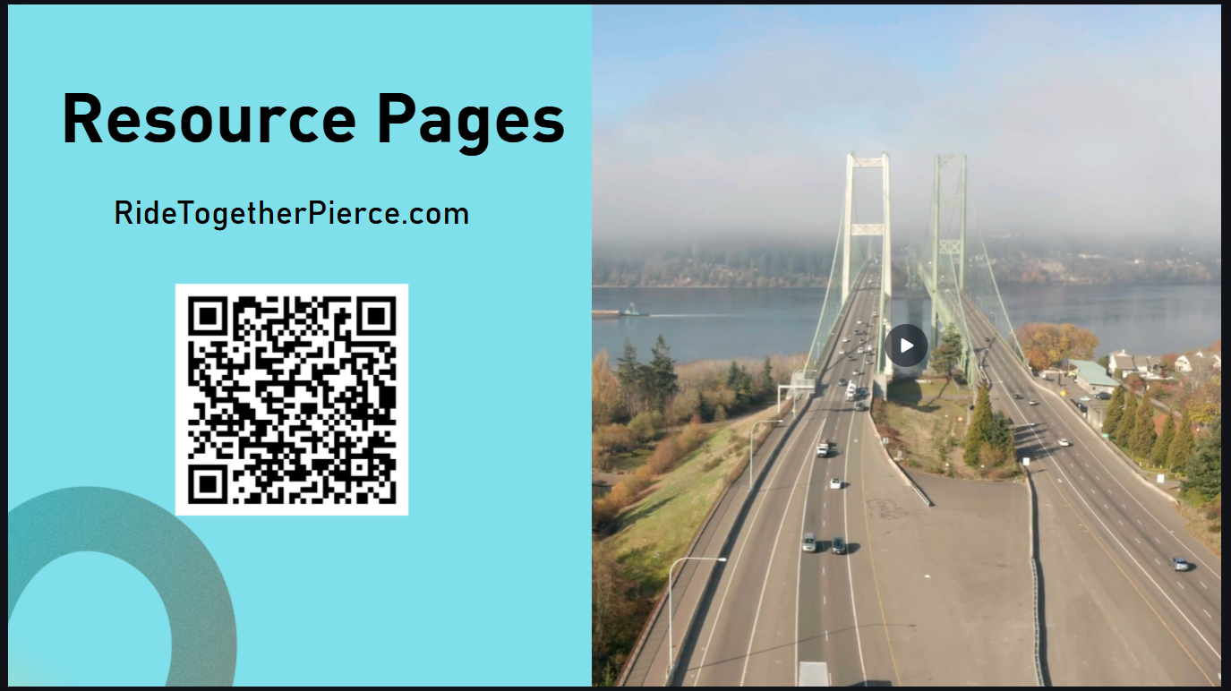
As a reminder, Ride Together Pierce has more resources for each of these sustainable modes. Use the QR code to explore them more in depth.

