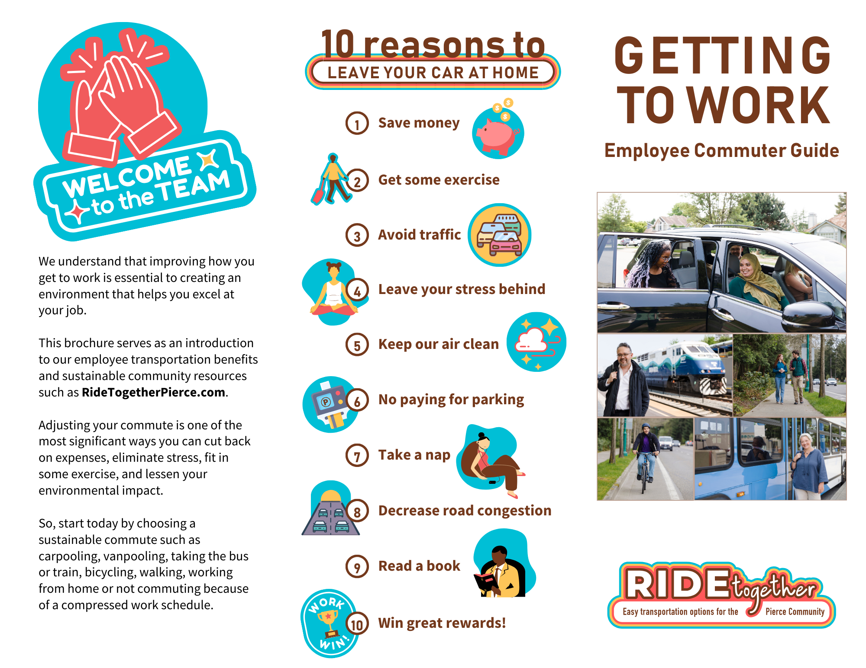
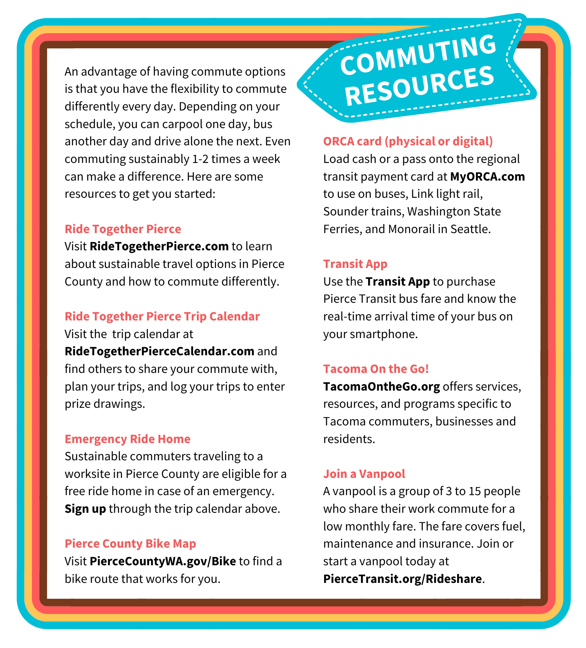

[Right-click the icon and add a photo of yourself.]
Hi! I’m [Name].
As your Employee
Transportation
Coordinator (ETC), I am
happy to assist you with
your commuting needs.
You can reach me at [ETC email address] or by calling [phone number].
Employee Benefits
Here at [company name], we are proud to offer the following commute benefits to our employees [list and describe only the elements you offer your employees]:
- Onsite Employee Transportation
- Coordinator and/or committee
- ORCA passes for all employees
- Subsidies for transit passes and vanpool fares
- Subsidies for carpoolers, bicyclists and walkers
- Financial and prize incentives
- Quarterly incentives
- Emergency Ride Home
- Preferential carpool/vanpool parking
- Promotional events
- Covered bicycle parking
- Flexible start and end times
- Showers and clothes lockers for bicyclists and walkers
- Compressed work schedules
- Telework options
- Employee recognition
- Cafeteria and post office services

