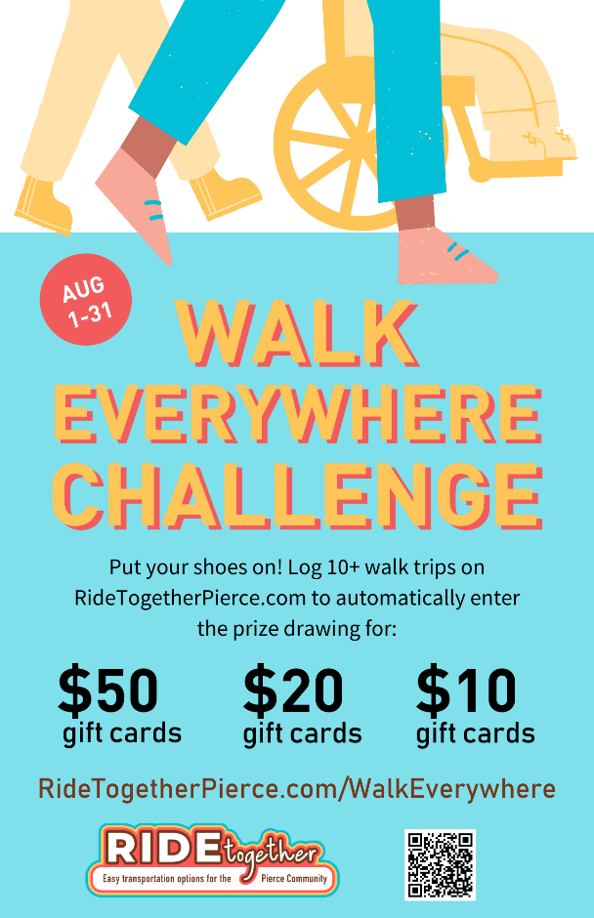
Promote Walk Everywhere Challenge

Campaign Date: August 1 - 31

Plan Your Campaign: Now
- Recruit a committee to plan and help promote the campaign.
- Connect with your Wellness and Sustainability teams to coordinate efforts.
- Request the CEO’s support and a budget.

Promote Walk Everywhere Challenge: July 15 – August 31
- Display the Walk Everywhere Challenge poster and PowerPoint slides on TVs or use as a web ad.
- Create a walk profile on an employee or student who walks; interview them regarding their experience. Announce in a newsletter, email, or company Intranet page.
- Submit an article for your July or August employee newsletter.
- Use sample email messages to encourage employees to participate in the Walk Everywhere Challenge.
- Repost Ride Together Pierce Facebook and Instagram posts.
- Promote walking maps and encourage an outing:
City of DuPont Walking Trail Maps | Historic Landmarks of City of Sumner | City of Puyallup Walking Map
City of Fife Walking Trails | City of Tacoma - Self Guided Walk Tours | Tacoma-Pierce County Walking Guide
- Ask employees to post pics of them walking on your social media.
  - Encourage participation in our photo contest by tagging @RideTogetherPierce and using the hashtag #PierceCountyWalks.
- Host a walk trivia contest (where can you find x along your walk, such as a sculpture, Little Free Library, nearest trail, and other walking trivia facts)
- Surprise walkers with healthy snacks or send them an e-gift card.
- Promote walking with “coffee, juice and muffins” in the lobby or break room.
- Hold individual or team challenges. Let employees earn points for prizes.
- Get families involved by creating family activities such as encouraging walks to neighborhood destinations and coloring contests.
- Hold a prize drawing for everyone who walks during the Walk Everywhere Challenge.
- Reimburse employees for walking gear.

After the Campaign: September 1-6
- Friday, September 6 is the last day for employees to record their trips in the online trip calendar.
- Conduct your worksite prize drawing using the calendar Reports tool.

Countywide Prize Drawing: Tuesday, September 10
- All Prize winners will be posted at RideTogetherPierce.com by Tuesday, September 10.
- By Friday, September 13, announce your campaign results and winners. Include the photos of the winners and/or the commuter profile in your announcement.
- Winners of the Bike Everywhere Challenge will automatically receive and claim their prizes from the trip calendar.

Resources
- Ride Together Pierce Walking Resources: RideTogetherPierce.com/Walk
- Downtown Tacoma Walking Resources: https://downtownonthego.com/go/walking
- Walking Safety Tips: verywellfit.com/walking-safety-rules-3435079
- Walk Your Way to Fitness: verywellfit.com/walking-4157093

