Emergency Ride Home Video
Voiceover Script and Notes
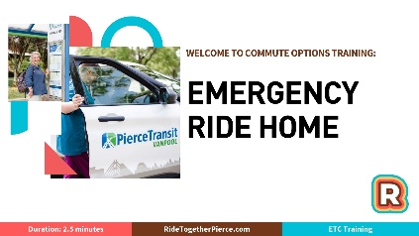
Slide 1:
Notes: ____________________________________________________
__________________________________________________________
__________________________________________________________
__________________________________________________________
Music

Slide 2:
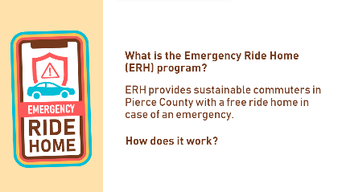
Notes: ____________________________________________________
__________________________________________________________
__________________________________________________________
__________________________________________________________
What is the Emergency Ride Home (ERH) program? It provides sustainable commuters in Pierce County with a free ride home in case of an emergency. How does it work?
Slide 3:
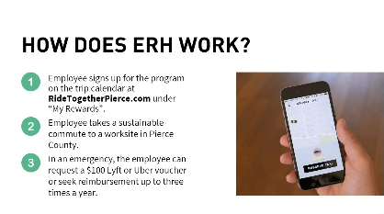
Notes: ____________________________________________________
__________________________________________________________
__________________________________________________________
__________________________________________________________
- The employee signs up for the program on the trip calendar, found under “My Rewards”.
- The employee takes a sustainable commute to a worksite in Pierce County.
- In an emergency, the employee can request a $100 Lyft or Uber voucher or seek reimbursement up to three times a year, all through the trip calendar.
Slide 4:
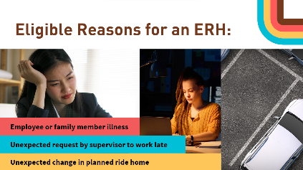
Notes: ____________________________________________________
__________________________________________________________
__________________________________________________________
__________________________________________________________
The Emergency Ride Home program can be used for:
- Personal or family illnesses,
- Unexpected overtime, or,
- A change in your planned ride home such as your carpool driver becoming ill.
Slide 5:
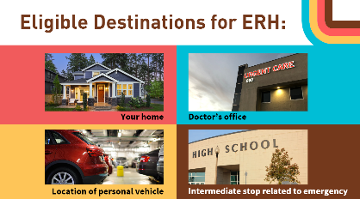
Notes: ____________________________________________________
__________________________________________________________
__________________________________________________________
__________________________________________________________
You can use the Emergency Ride Home program to go home or where your personal vehicle is located, such as a train station or park and ride, or to the doctor’s office. You can also make intermediate stops that relate to your emergency such as picking up a kid to go to the doctor’s office.

Slide 6:
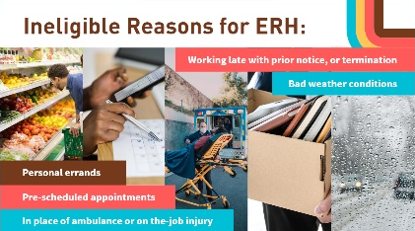
Notes: ____________________________________________________
__________________________________________________________
__________________________________________________________
__________________________________________________________
The Emergency Ride Home program cannot be used for running personal errands, going to pre-scheduled appointments, bad weather conditions, in place of an ambulance ride, going to the hospital due to an on-the-job injury, working late with prior notice or after being terminated.

Slide 7:
Notes: ____________________________________________________
__________________________________________________________
__________________________________________________________
__________________________________________________________
Time for a pop quiz!
Slide 8:
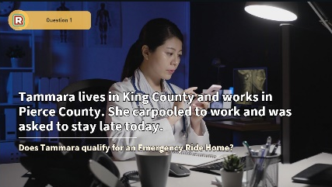
Notes: ____________________________________________________
__________________________________________________________
__________________________________________________________
__________________________________________________________
Tammara lives in King County and works in Pierce County. She carpooled to work and was asked to stay late today. Does Tammara qualify for an Emergency Ride Home?
Slide 9:
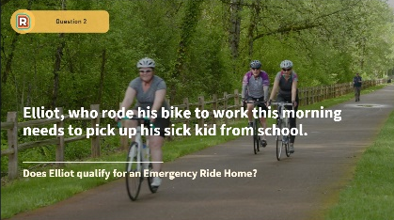
Notes: ____________________________________________________
__________________________________________________________
__________________________________________________________
__________________________________________________________
Elliot, who rode his bike to work this morning needs to pick up his sick kid from school. Does Elliot qualify for an Emergency Ride Home?
Slide 10:
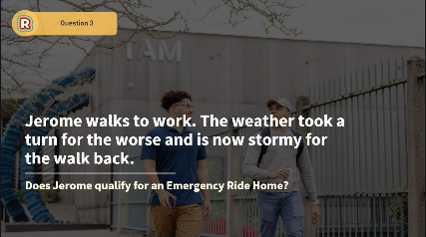
Notes: ____________________________________________________
__________________________________________________________
__________________________________________________________
__________________________________________________________
Jerome walks to work. The weather took a turn for the worse and is now stormy for the walk back. Does Jerome qualify for an Emergency Ride Home?

Slide 11:
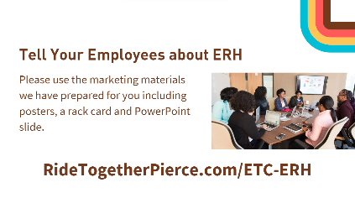
Notes: ____________________________________________________
__________________________________________________________
__________________________________________________________
__________________________________________________________
Tell Your Employees about Emergency Ride Home program. Please use the marketing materials we have prepared for you including posters, a rack card and PowerPoint slide. RideTogetherPierce.com/ETC-ERH
Slide 12:
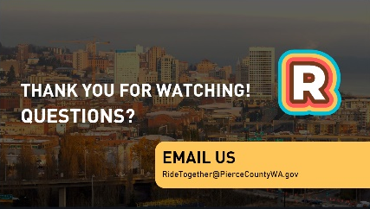
Questions? Email us at RideTogether@PierceCountyWA.gov.

