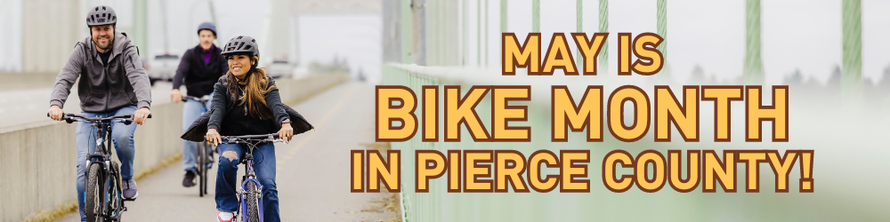
Promote Bike Month: Bike Everywhere Challenge, May 1-31

Plan Your Campaign: Now
- Recruit a committee to plan and help promote the campaign.
- Connect with your Wellness and Sustainability teams to coordinate efforts.
- Request managements support and a budget.

Ideas to promote Bike Month: April 13/20 - May 31
- Display the Bike Everywhere Challenge posters and PowerPoint slides on TVs or use as a web ad.
- Create a bicyclist commuter profile on an employee or student who rides their bike; interview them regarding their experience. Announce in a newsletter, email, or company intranet page. Share your interview with Ride Together Pierce for us to post on social media.
- Submit an article for your April or May employee newsletter.
- Use the template emails to encourage participation in the Bike Everywhere Challenge.
- Encourage employees to practice their bike commute so that they are ready to commute to the workplace. Offer to help employees find a bike buddy.
- Make sure your bike racks, locker rooms, shower rooms are in good shape and accessible. If there’s debris, overgrown vegetation or broken infrastructure, please work with your employer to address concerns ahead of time.
  - Report any road/trail maintenance issues to your local government.
- Ask employees to post photos of them riding their bike on your social media. Ask them to tag us on Facebook or Instagram to earn a $10 Starbucks card: @RideTogetherPierce.
- Promote events posted on the City of Tacoma’s Pierce County Bike Month page.
- Keep an eye out for local bike shops and businesses hosting bike riding classes or repair lessons, such as 2nd Cycle in Tacoma, or REI.
- Friday, May 15 is National Bike to Work Day: A community event celebrating people on bikes. Employers and volunteers are encouraged to host a Celebration Station in front of their workplace or along a popular bike route as a simple and fun way to support and celebrate bicyclists, usually offering snacks, bike maps, resources and more.
  - Register your event on Cascade Bicycle Club’s website to receive support from them.
  - You can keep it internal by putting out beverages and snacks for bicyclists in the lobby or break room.
- Recruit Team Captains and host team challenges.
- Hold a prize drawing for everyone who rode their bike during the Bike Everywhere Challenge.
- Do you work on a campus with multiple buildings or have places nearby employees can travel to for lunch or meetings? Consider starting a bike fleet with a couple of bikes so employees choose bikes over cars. Convert a spare room or space under the stairwell into bike storage and discuss site improvements with facilities.
  - Here is a sample bike fleet setup checklist.
- Invite a nearby bike shop to perform bike tune-ups for employees. Pay for the easy tune-ups or offer an employee discount. Some local mobile mechanics include Goldspoke Cycle Repair (based in Tacoma), Steilacoom Bike Co., NW Bike Mechanic (based in Puyallup), South Tacoma Bike Repair, Bespoke BikeWorks (serves all of Pierce County)

After the Campaign: June 1 - 7
- Sunday, June 7 is the last day for employees to record their trips in the online trip calendar.
- Conduct your worksite prize drawing using the calendar Reports tool.

Countywide Prize Drawing: Wednesday, June 10
- All prize winners will be posted at RideTogetherPierce.com by Wednesday, June 10.
- By Friday, June 12, announce your campaign results and winners. Include the photos of the winners and/or the commuter profile in your announcement.
- Winners of the Bike Everywhere Challenge will claim their prizes via an email we send through the online gift card mall website Tango.com.
- Ride Together Pierce will contact the winning Bike Team captains regarding selecting a day for the pizza party.

Resources
- Pierce County Bike Map: PierceCountyWA.gov/BikeMap
- Low-Cost Bicycle Helmets: PierceCountyWA.gov/Helmets
- Bicycle Commuting Tips & Tricks: RideTogetherPierce.com/DocumentCenter/View/83/Bicycle-Commuting-Tips--Tricks-PDF?bidId=
- Washington State Bicycle Commute Guide: RideTogetherPierce.com/DocumentCenter/View/628
- Washington State Bike Laws: RideTogetherPierce.com/152/Bicycle-Safety
- Bicycle Benefits: RideTogetherPierce.com/BicycleBenefits
- Bikes on Buses: RideTogetherPierce.com/BikesonBuses
- Pierce County Bike Month Events Calendar: https://tacoma.gov/government/departments/public-works/mobility-options/bicycling/bike-month
- Bikes on Trains or Light Rail: SoundTransit.org/ride-with-us/know-before-you-go/bringing-your-bike
- Trip planner and cost calculator: RideTogetherPierceCalendar.com
- Bike Buddies on the trip calendar:
  - Find a Bike Buddy: https://help.rideamigos.com/hc/en-us/articles/33474217799063-Find-a-Ride-New
  - Offer to be a Bike Buddy: https://help.rideamigos.com/hc/en-us/articles/33474766987031-Offer-a-Ride-New

