Bike Everywhere Challenge Emails

Send week of April 13 or 20:
Get Ready for Bike Month— Great opportunities await.

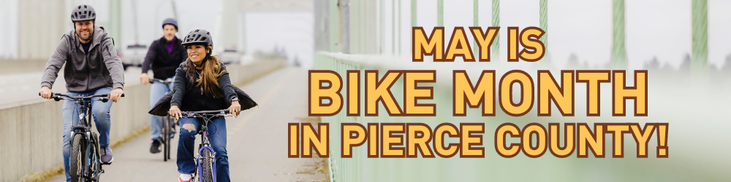

Bike Month starts May 1, so this is the perfect time to prep for your new ride. With the weather warming up, why not take a break from high gas prices and arrive by bike?

Ride Together Pierce invites YOU to participate in this year’s Bike Everywhere Challenge, which encourages people to ride their bikes to work, the gym, store, coffee shop, friends and family, and more. Log 10 bike trips on the Ride Together Pierce trip calendar this May to enter to win $20 and $50 prizes. That’s 10 one-way trips, or 5 roundtrips.

Join or form a bike team! You can participate individually, and as a team! Join or form a team with friends, colleagues, etc. on the trip calendar for some friendly competition with other cyclists in Pierce County! Top 3-5 teams will celebrate their victory with a pizza party by Ride Together Pierce.

Need a bike? Stop by the 15th Annual Pierce County Bike Swap on Saturday, April 25 from 10 a.m. to 2 p.m. at the Tacoma Community College in Tacoma.  At this event you can sell your bike, find your next bike, get a bike helmet, learn about bicycling resources in Pierce County, meet with local bike shops, practice your riding skills and so much more. | 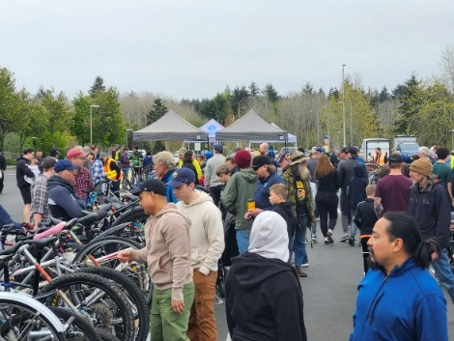

Here are some bike resources to get you started:

- Login or sign up for the trip calendar at RideTogetherPierce.com to plan your route, register your regular commute, and find a bike buddy to join you on your ride, or become a team captain.
- Pierce County Bike Map
- Affordable Helmets (call locations to confirm first)
- Bicycle Shops in Pierce County
- Tacoma On the Go Bicycling Resources
- Ride Together Pierce (County) Bicycling Resources
- Bicycle Benefits Program in Pierce County
- Check out Pierce County Bike Month page to find a bike event near you
Get all the latest news and events by following Ride Together Pierce on Instagram and Facebook or subscribing to the monthly newsletter.

Are you a looking for a bike buddy for your commute? Let me, your Employee Transportation Coordinator, <phone number> or <e-mail address>. know! While you can use the trip calendar to find bike buddies across the County, I can help you partner with a bike buddy at work, and find others to form bike teams.

Send May 1:
Let Bike Month Commence, Start Rolling!


Ready, set, roll! Bike Month is officially here. Get rewarded for riding your bike to destinations like the grocery store, coffee shop, work, park—everywhere. Riding your bike is one of the best ways you can enjoy nature, socialize, get exercise and reduce your travel expenses.

Prizes for logging bike trips on the trip calendar this May include:
- $50 gift cards to a local bike shop of your choice
- $20 gift codes
- Team pizza party for top 3-5 bike teams

<Add company prize drawing information here>.

To be entered to win these prizes during Bike Month, May 1-31, all you need to do is ride your bicycle to destinations at least 10 times and log the trips by June 7. That’s 10 one-way trips, or 5 roundtrips.

Enter the prize drawing online by logging your trips in the trip calendar at RideTogetherPierce.com. Get started by logging into the trip calendar, or creating an account today.

By logging your bike trips on the trip calendar, you can also track your money, gas, and emission savings, and find bike buddies.

For more information contact me, your Employee Transportation Coordinator, at <phone number> or <e-mail address>.

Send Thursday, May 14:
3 Reasons to Keep on Pedaling for Bike Month
You still have plenty of time to log 10 bike trips to be eligible for $50 and $20 prizes during Bike Month! Head over to RideTogetherPierce.com and log your trips on the trip calendar for your chance to win. Going to a game, a restaurant or museum (third Thursdays are free)? Why not arrive by bike? You can combine your bike trip with transit or train to shorten the ride or avoid that hill.

Three great reasons to keep pedaling for Bike Month:
- This is an excellent time to practice your bike commute by planning your route on the trip planner or Pierce County Bike Map and trying it out on the weekend.
- Bicycling is a fun way to destress. Take in the sights and sounds that you would miss when you drive a car. What do you see along your route? What are you enjoying with your financial and environmental savings?
  - Share a photo on Instagram or Facebook and tag us @RideTogetherPierce to win a $10 Starbucks gift card.
  - Submit a Commuter Profile and win a $20 gift card.
- Get the family involved! Get fitted for helmets (confirm with locations first), bike to the park or enjoy a trail and grab a treat.

For more information contact me, your Employee Transportation Coordinator, at <phone number> or <e-mail address>.

Send Friday, May 29:
Thank you for making Bike Month a success!

Thank you to everyone who took part in Bike Month! Did you try bicycling as a new way to travel to work, run errands, or visit friends and family during the Bike Everywhere Challenge, May 1-31?

Everyone who rode their bike to a destination 10 times in May will be entered in our company drawing for <prizes offered by your company>.

Log your bike trips in the online calendar at RideTogetherPierce.com by the end of Sunday, June 7 for a chance to win Bike Everywhere Challenge prizes including $50 and $20 gift cards.

For more information contact me, your Employee Transportation Coordinator, at <phone number> or <e-mail address>.

Send Wednesday, June 10:
Check out our AMAZING Bike Month results!

<000> employees here at <Company Name> participated in the Bike Month campaign! Together we drove <000> fewer miles, gained health benefits, and reduced greenhouse gas emissions.
<000> Total Distance
<000> Total Cost Savings
<000> Total CO2e Savings

I’m pleased to announce that <prize winner’s name> won <description of the prize> in our Bike Everywhere Challenge! Congratulations <prize winner’s name> and thanks again to everyone who participated!

