Find Your Commute Buddy 2026 Emails

Send September 1
Attach Find Your Commute Buddy Poster as a PDF

It’s Time to Find Your Commute Buddy
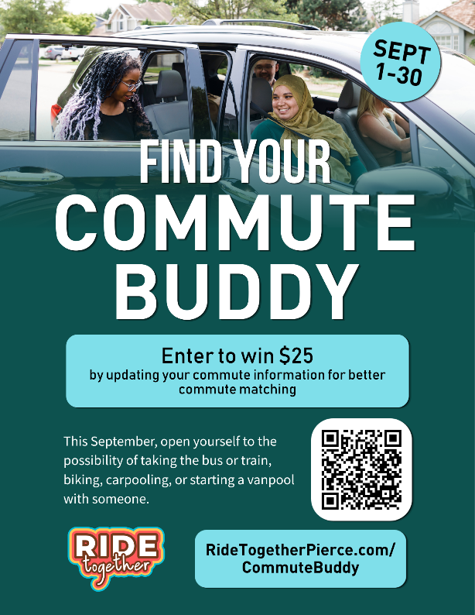
Ride Together Pierce invites you to Find Your Commute Buddy this September for a chance to win one of eight $25 prizes! Simply add or update your commute in the Trip Planner between September 1–30 and you’ll be entered to win.

Here’s how:
- Sign up for a trip tracking account at RideTogetherPierce.com.
- Save your current home and work address under Account and then Addresses. (Your exact home and work address is always hidden from public view.)
- Confirm the details on your account like your work network. That's it to be entered!

Once you add or update your commute, use the Pool tab in the Trip Calendar to find potential matches with others who share your commute route. You can search for carpool buddies, vanpool buddies, transit buddies, even walk or bike buddies.

Already have your commute in the database? Be sure to confirm and save your commute before the end of September to be entered to win and find commute buddies.

Why now? We’re gearing up for the statewide Switch Your Trips campaign in October, when you can win up to $1,500 for choosing sustainable commutes. Get a head start by finding your commute buddy now!

Need help finding a commute buddy? Contact me, your Employee Transportation Coordinator, at <phone number> or <e-mail address>.

Send September 14
Attach Find Your Commute Buddy Poster as a PDF

All it takes is 3 minutes to enter to win $25!

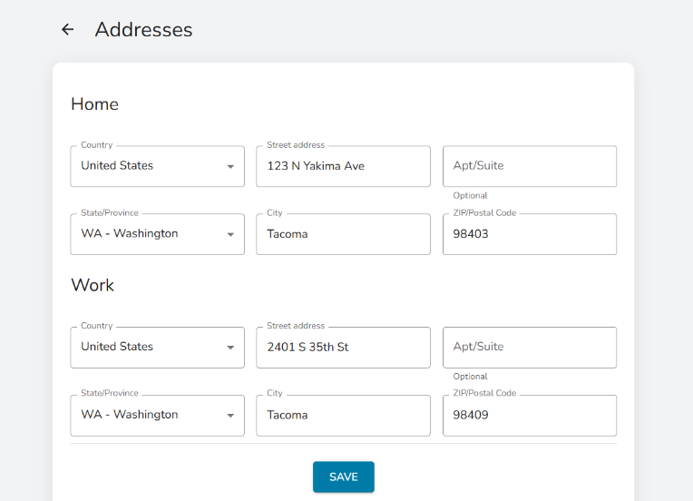
We’re halfway through the Find Your Commute Buddy campaign. Have you found a commute buddy yet?

It only takes three minutes to enter to win $25! Before September ends, create an account on the rip tracking calendar at RideTogetherPierce.com and add your commute. The Trip Planner will show you other commuters who share your route, whether you’re looking for carpool, vanpool, transit, walking, or biking companions.

Already have your commute in the database? Simply confirm and save your commute information before the end of September to be entered to win.

Why now? We're gearing up for the statewide Switch Your Trips campaign in October, when you can win up to $1,500 for choosing a sustainable commute. Get a head start by finding your commute buddies now!

Let’s find a sustainable commute that works for you:
- Carpool – Your Employee Transportation Coordinator can help you find coworkers who live along your commute.
- Vanpool – You only need three people to start a vanpool. They can be your coworkers or other commuters traveling a similar route. Find existing vanpools on the trip planner.
- Bus – Bring exact cash, tap to pay, or <purchase an ORCA card/ use your employer provided ORCA card> for easy boarding.
- Light Rail – Sound Transit Link Light Rail expansions can take your farther than you might think, and you can bring your bike on board!
- Sounder Train – Great for commuting or leisure, the Sounder Train also runs for special events including Seahawks games!
Need help finding a commute buddy or using the Trip Planner? Contact me, your Employee Transportation Coordinator, at <phone number> or <e-mail address>.

