Rider Rewards 2026
Emails

Send December 17-24:
Announcing a new, year-round campaign: Rider Rewards!

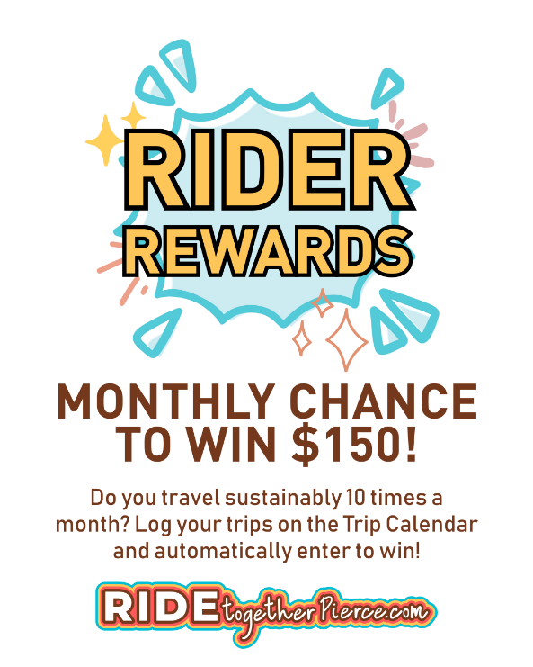
Ride Together Pierce is proud to present a new monthly rewards program: Rider Rewards! This program will reward one lucky sustainable traveler with $150 each month* in 2026!

All you have to do is take 10 sustainable trips (that’s 5 round trips) a month and log your trips on the Ride Together Pierce trip calendar to be automatically entered into the $150 prize drawing. These can be commutes to work, or personal trips.

Eligible modes of transportation include walking, biking, rolling, carpooling, ridesharing (also known as vanpooling), taking transit (bus, train, light rail), working a compressed work schedule or teleworking.

Here are some resources to get you started:
- Carpool – Share the ride to a restaurant, show, or other outing.
- Rideshare (also known as vanpool) – Commute to work once a week, or every day with your coworkers. Start your journey at PierceTransit.org/Rideshare.
- Bus – Leave your parking woes behind and hop on the bus.
- Light Rail – Catch the T Line through Tacoma or the 1 Line from Federal Way up north (extension opened December 2025!)
- Sounder Train – Hop on the train to the next Seahawks’ game, show or other outing.
- Compressed work schedule – Does your job seem like a good fit for longer workdays so you can take an extra day off?
- Teleworking – Does your job seem like a good fit for working remotely, even a couple times a week?
What are the campaign requirements? You must be at least 18 years old, and your trips must have an origin or destination in Pierce County (exercise trips do not count).
Looking for additional ways to win?
- Share a photo: Share a photo of your sustainable commute along with 2-4 sentences describing your commute (why you enjoy it, how much time/money you save, etc.) to be featured in a Ride Together Pierce newsletter and win a $10 Starbucks gift card! You can share the photo via email or Direct Message Ride Together Pierce on Instagram or Facebook.
- Submit a Commuter Profile: Share more details about the value of your sustainable commute along with a photo by submitting a Commuter Profile and earn a $20 gift code!

For help finding a sustainable commute, contact me, your Employee Transportation Coordinator, at <phone number> or <e-mail address>.

*Every month except for May, September and October when Ride Together Pierce runs other prized promotions.
Ride Together Pierce is an outreach program and information resource brought to you by Pierce County to encourage the use of sustainable transportation options through education, incentives and partnerships with large employers.
Send beginning of the campaign month:
“Rider Rewards” Begins Today
Do you:
- Carpool or rideshare (also known as vanpool),
- Ride the bus/light rail/train,
- Walk/roll/bike,
- Telework or work a compressed schedule?

If you do any combination of these at least five times a month, you can be in the running for a $150 prize!

How so? Ride Together Pierce is hosting a monthly prize drawing of $150 for those who take 10 sustainable trips a month and log those trips on the trip calendar. Once you log 10 trips, you will automatically be entered into the prize drawing.

The only requirements are that you must be at least 18 years old, and your trips must have an origin or destination in Pierce County (exercise trips do not count).
<Add company prize drawing information here>.

Need help getting started? Ride Together Pierce has resources to help.

Here are some sustainable trip ideas:
- Carpool or take a bus/train to a concert, play, movie, comedy show or other performance around town.
- Visit attractions near you! On the third Thursday of each month, select museums around the region offer free admissions and often feature special activities.
- Going out to celebrate? Leave the car behind and let someone else do the driving.
- Just need a few things from the grocery store? Consider walking or biking there.

For more information contact me, your Employee Transportation Coordinator, at <phone number> or <e-mail address>.

Ride Together Pierce is an outreach program and information resource brought to you by Pierce County to encourage the use of sustainable transportation options through education, incentives and partnerships with large employers.
Send middle of the campaign month:
Halfway through this month’s “Rider Rewards”

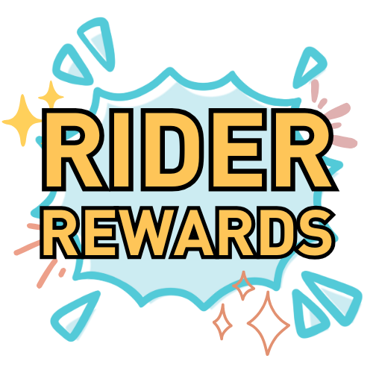
Have you taken any non-driving trips this month? You’re already on your way towards being eligible to win $150!

How to enter the prize drawing:
- Take 10 sustainable trips this month (or five round-trips) using an eligible mode of transportation listed below.
- Create an account or login to the Ride Together Pierce trip calendar.
- Log your sustainable trips on the trip calendar before the 7th of the following month.
- That’s it! You are automatically entered into the $150 prize drawing. Winners will be contacted within the following week.

Eligible modes of transportation include:
- Walking, biking, rolling
- Taking transit (bus, light rail, train)
- Carpooling, ridesharing (also known as vanpooling)
- Working a compressed work week or teleworking
  - If you have a compressed work schedule, you can log the extra days you have off due to this schedule. Only 2 extra days off are required to qualify for the prize drawing.
    - For example, if you work 10-hour days and have Fridays off, log Friday as your Compressed Work Day Off.
  - If you telework, log the days you telework on the trip calendar and include the distance you would have traveled if you were commuting.
    - For example, if you worked remotely on Friday and avoided a 6-mile commute, log a telework "trip" for that day and add the mileage you avoided driving.

<Add company prize drawing information here>.

For more information contact me, your Employee Transportation Coordinator, at <phone number> or <e-mail address>.

*Every month except for May, September and October when Ride Together Pierce runs other prized promotions.
Ride Together Pierce is an outreach program and information resource brought to you by Pierce County to encourage the use of sustainable transportation options through education, incentives and partnerships with large employers.
Send last week of the campaign month:
Last days for this month’s “Rider Rewards”

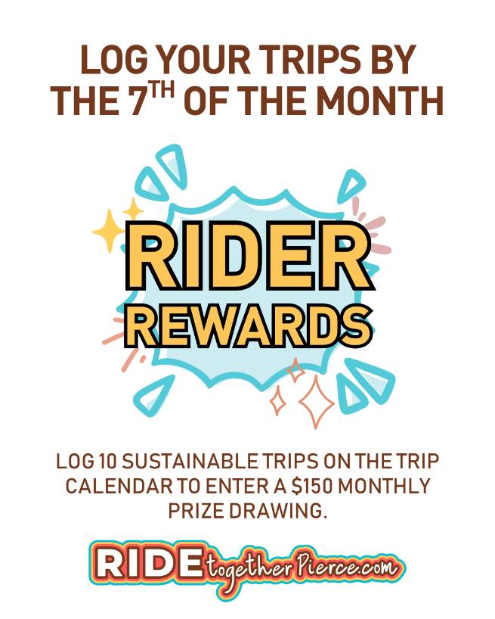
If you took 10 sustainable trips this month, for work or personal reasons, be sure to log those trips on the Ride Together Pierce trip calendar to enter the monthly $150 prize drawing! Log your sustainable trips by the 7th of next month for your chance to win.
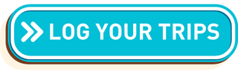
<Add company prize drawing information here>.

Didn’t make it to 10 trips this month? No worries! Ride Together Pierce holds this prize drawing monthly*! You can try again next month for your chance at $150.

Looking for additional ways to win?
- Share a photo: Share a photo of your sustainable commute along with 2-4 sentences describing your commute (why you enjoy it, how much time/money you save, etc.) to be featured in a Ride Together Pierce newsletter and win a $10 Starbucks gift card! You can share the photo via email or Direct Message Ride Together Pierce on Instagram or Facebook.
- Submit a Commuter Profile: Share more details about the value of your sustainable commute along with a photo by submitting a Commuter Profile and earn a $20 gift code!

For more information contact me, your Employee Transportation Coordinator, at <phone number> or <e-mail address>.

*Every month except for May, September and October when Ride Together Pierce runs other prized promotions.

Ride Together Pierce is an outreach program and information resource brought to you by Pierce County to encourage the use of sustainable transportation options through education, incentives and partnerships with large employers.

